**Rational Team Concert**

**Quick Start Tutorial**

**Ration**

Page Left Intentionally Blank

**Table of Content**

[1. Introduction 6](#_Toc475547769)

[2. Terminology 6](#_Toc475547770)

[3. Project Area Preparation 7](#_Toc475547771)

[3.1 Defining Timelines and Iterations 7](#_Toc475547772)

[3.2 Creating Team Areas 9](#_Toc475547773)

[3.3 Defining Roles 10](#_Toc475547774)

[3.4 Defining Releases 11](#_Toc475547775)

[3.5 Defining Categories 12](#_Toc475547776)

[3.6 Defining Work Item Types 14](#_Toc475547777)

[4. Configuration and Change Management 16](#_Toc475547778)

[4.1 Creating Work Items 16](#_Toc475547779)

[4.2 Assigning Work Items 19](#_Toc475547780)

[4.3 Updating Work Items 21](#_Toc475547781)

[4.4 Queries 22](#_Toc475547782)

[4.4.1 Using Predefined Queries 23](#_Toc475547783)

[4.4.2 Creating New Queries 24](#_Toc475547784)

[5. Rational Team Concert source control 27](#_Toc475547785)

[5.1 Check-out and Check-in 35](#_Toc475547786)

[5.2 Accepting Incoming Changes 37](#_Toc475547787)

[5.3 Suspending Change Sets 37](#_Toc475547788)

[5.4 Finding and Resolving Conflicts 39](#_Toc475547789)

[5.5 Viewing History of Files 40](#_Toc475547790)

Page Left Intentionally Blank

# Introduction

IBM Rational Team Concert integrates task tracking, source control, and agile planning with continuous builds and a configurable process to adapt to the way you work. This tutorial is based on version 3.0.1.1 of RTC using the scrum template and the Eclipse client.

The objective of this tutorial is to explain the basic features and helps getting started with Rational Team Concert. More information can be found in the online library of Jazz.net: https://jazz.net/library If you have comments or questions regarding this document, Jazz or Rational Requirements Team Concert, please contact catedra.ibm.fiupm@gmail.com

# Terminology

**Change set:** a repository object that collects a related group of file, folder and symbolic link modifications within a component.

**Iteration:** Projects are organized into a series of development periods called iterations. Each timeline contains a hierarchy of iterations, which can define start and end dates.

**Process:** the collection of roles, practices, rules, and guidelines that are used to organize and control the flow of work. The project process is defined in a project area and can be further customized in a team area.

**Project area:** A system representation of a software project. The project area defines the project deliverables, team structure, process and schedule.

**Report:** A set of data deliberately laid out to communicate business information.

**Roles:** Roles identify the functions of team members. Permissions for specific operations can be assigned to roles at the project level or within a team area.

**Sandbox:** An area

on a file system where a developer can modify and test source code in isolation, before returning it to the source control component and sharing it with other developers.

**Snapshot:** A record of the data in the data warehouse that is used for reporting.

**Tag:** An identifier that groups related artifact.

**Team area:** The structure of the project teams is defined by a hierarchy of team areas. Use team areas to manage team membership, roles assignments and team artifacts.

**Timeline:** represents an area of activity within a project that typically has its own schedule, deliverables, teams, and process.

**Work item category:** Work item categories group work items by the various components or functional areas of your project. Each category is associated with a team area whose members are responsible for developing that component.

# Project Area Preparation

Before the start of a project it is advisable to configure the team and the process. Although these tasks can also be performed in the Eclipse client, this section uses the web client. All of the following tasks require the user to go to the Application Administration page, which can be done as follows:

1. Click on the Administration icon  and then click Manage This Project Area



## Defining Timelines and Iterations

When a project area is created it normally has a default timeline, but you can create additional timelines as well as a hierarchy of iterations for each of them.

1. On the Application Administration page of the web client, click the Timelines tab.
2. To create a timeline, click Create Timeline. Specify an identifier, which appears in the Process Configuration Source code. You can also specify a display name, which appears wherever the timeline appears in the user interface. If you do not specify a display name, the identifier is used in the user interface. You can enter start and end dates for the timeline and designate the timeline as the project timeline. Click OK. You cannot nest timelines.



1. To create an iteration, select the timeline or iteration within which to create the iteration, then click Create Iteration. Specify an identifier and, optionally, a display name. Optionally, enter start and end dates for the iteration. To enable the iteration for an iteration plan, click A release is scheduled for this iteration. Only iterations with scheduled releases are eligible for iteration plans. Click OK.



1. To set an iteration as the current iteration, select it and click the Set the Selected Iteration as Current icon.



## Creating Team Areas

Team areas can be created to assign users in particular roles for work on a timeline or a particular set of deliverables. You can create a team area within an existing project area or another team area to establish a team hierarchy.

1. On the Application Administration page of the web client, click the Overview tab.
2. In the Team Area Hierarchy pane, click Create Team.



1. In the Team Area Name field, enter a team name.
2. Optional: To change the team area timeline, in the Timeline field, select a timeline from the list.
3. Optional: To add a user to the team:

* In the Members or Administrators pane, click Add.
* In the Contributor Selection window, enter the name of a user to search for, or click Show All. Remember to use the name or last name of the user instead of the user id.
* In the Matching users pane, select a user.
* Click Add.

1. Add an optional summary and description for the team and click Save.

## Defining Roles

As part of the process definition, RTC allows defining new roles.

1. On the Application Administration page of the web client, click the Roles tab.
2. Do one of the following:

* To add a role, click the Add Role icon. Enter an identifier for the role. This ID is used in the process configuration code, and in the Role Details lists when you add members to a team. Optionally, enter a name for the role. To indicate that the role is intended to be assigned to only one team member, set the Cardinality attribute to single. To indicate that the role is intended to be assigned to multiple team members, set the Cardinality attribute to many. Optionally, enter a description of the role in the Description field.
* To remove a role, select it and click the Remove Role icon.



1. Click Save to save the changes to your project area.
2. To modify Permissions of a role, click the Permissions tab.
3. In the Configuration pane, select the timeline or iteration.
4. In the Details pane, select the roles and the permitted actions for each of them.
5. Click Save to save the changes to your project area.



## Defining Releases

Releases are the products of a team's work. The releases that you identify appear in the list associated with the Found In field on a work item.

1. On the Application Administration page of the web client, click the Releases tab.
2. Click the Add release button. Enter a name and brief description for the release. Optionally, select a creation date for the release. To limit visibility of the release to members of this project area team, click the Hide Release Visibility from All but Members of the Team checkbox. Click OK. The release appears in the Releases table. You can change the initial visibility setting of a release by clicking the checkbox in the Restrict Visibility column.



1. To adjust the order in which releases appear in the Found In field list, select a release in the table, open the Actions drop-down menu and click Move Up or Move Down.
2. When you finish defining releases, click Save to save your changes.

## Defining Categories

Categories identify the various components or functional areas of your project. Each category is associated with a team area whose members are responsible for developing that component. The categories that you define appear as the choices available in the Filed Against field in the Work Item Editor.

1. On the Application Administration page of the web client, click the Categories tab.
2. To create a category and add it to the project area:

* In the toolbar, click the Action Menu button to open the menu, then click Add Category.
* Optionally, to nest a new category within an existing category, highlight the existing category, then click the checkbox in the Actions column of that category's row. Click the Action menu button in the same cell.
* Enter a name for the category and click OK.



The new category appears in the table of categories and associated team areas. By default the new category is associated with the team area that is associated with the top-level category.

1. To associate a category with a team area:

* Optional: Select a timeline. The default timeline is <any>, meaning that the association applies to all timelines. If your process includes multiple timelines, you can specify a different association for each timeline. When a user creates a work item, it is assigned to a team area based on its category and the timeline of its Planned For iteration.
* Select the category.
* Click the corresponding cell in the Associated Project/Team Area column.
* Select the team area to associate it with, then click Associate.

If you specified different associations based on different timelines, then in the table of categories and associated team areas, the associations change when you select different timelines in the Timeline menu. The process defined for the associated team area is the process that users follow for processing the work item.

1. To remove an old category from the table, select it, then click the Archive All Selected button. To view archived categories, click Show Archived. Archived categories appear greyed out. To restore an archived category, select it and click the Unarchive Selected button.
2. You can move a category from one spot in the hierarchy to another by dragging and dropping it using the move control in the Actions column. A horizontal line indicates that it will be moved to between the category above and the category below the line when you drop it. A highlighted category indicates that it will be nested within the highlighted category when you drop it.
3. Click Save to save your work item category changes.

## Defining Work Item Types

In the scrum template, the following work item types are available:

* Adoption Item: Tracks when changes by one team must be adopted by another team
* Defect: Identifies a bug
* Retrospective: Records what went well and what did not go well in the recently completed iteration
* Story: Describes part of a use case
* Task: Describes a specific piece of work
* Impediment: Tracks things that get in the way of progress
* Epic: Used when a story is too big to complete in a single iteration (sometimes called a "sprint") or when there are too many unknowns to estimate the amount of work. An Epic can be broken down into several stories.
* Track build item: Typically created from a build result to track the fixes that are needed for a failed build

Each work item type has a state transition model that defines the states a work item can be in and the actions to move the work item throughout states. A typical state transition model provides a path from a submitted or opened state to a resolved or closed state. In states between those start and end points, team members can indicate their progress in addressing the issues described in the work item.

1. On the Application Administration page of the web client, click the Categories tab.
2. In the Choose the Work Item Type to edit section, click Add.



1. In the Add type window:

* Enter an ID for the new type. By default, the Name field is populated with the same value that you enter into the ID field. You can edit the Name field value.

1. Click Edit in the icon field and select an icon. The process templates include a set of icons that you can use. If you want an icon that is not in the list, you click Browse and navigate to a graphics file to use as the icon for the new work item type. When you are done, click OK.



1. You can add attributes in the Attributes pane.



1. State transitions of each work item type are represented as Workflows. To define the workflow for a work item type, click the Workflows section.



# Configuration and Change Management

All the activities in this section are performed using the Eclipse client.

## Creating Work Items

Create a work item to submit a defect, task, or other type of work request that the project uses.

1. In the Team Artifacts view, expand the project area node, right-click Work Items, and select New > Work Item. In the Create New Work item wizard, select the work item type, such as Defect, Enhancement, or Task. Click Finish.



1. Enter or select values for the following fields on the Overview tab:

* Summary: A brief headline that identifies the work item.
* Type: The type of work item. Commonly available types are Defect, Task, and Story. You can customize the project to include additional types.
* Filed Against: A category that identifies the functional area that the work item belongs to. For example, your project might have GUI, Build, and Documentation categories. Each category is associated with a team area; that team is responsible for responding to the work item. If you are unsure of the category, you can enter the Description, then click the Guess Category button. The Guess Category button attempts to guess the correct category by using the text in the Summary and Description fields to search for similar work items.
* Severity: An indication of the impact of the work item, such as Minor, Normal, Major, or Critical.
* Found In: The release that the work item refers to. After a release is created, it becomes available as a choice in the Found In field of work items in the same project area as the release. Usually, this field is used for the work item type Defect, to identify the release in which the defect is raised.
* Description: A detailed description of the work item. For example, the description for a defect might include a list of steps to follow to reproduce the defect. Any descriptions that are longer than 32KB are truncated(first 32KB is retained), and the entire description is added as an attachment. Currently, this feature is available only in the RTC Eclipse Client and not in the Web Client.



1. On the Links tab, add attachments, screen captures, and subscribers, and specify related work items.



1. Click Save to save the work item.

## Assigning Work Items

Assign a work item to a specific user.

1. Click the Find Potential Duplicates icon to see if another work item has been submitted about the same issue. If a duplicate work item exists, set the state of one of the work items to Resolved and set its Resolution to Duplicate. Then, click the Links tab in one of the work items, and click Add > Add Related to find and link to the other work item.



1. The Owned By list contains all members of the team area that is associated with the work item category. Select an owner from that list or click more at the bottom of the list to search for a member of another team.
2. Set the value in the Planned For field to a planned iteration for resolving the work item, and enter a value in the Due Date field.
3. To add a comment, in the Discussion section, click Add Comment, and enter your text.



1. An approval is a request for other users to review, approve, or verify the work that is done to resolve the work item. To add an approval:

* Click the Approvals tab.
* Click New: Approval, select the type of approval, and specify the due date.
* Specify the user or users who are responsible to approve the resolution by clicking Add Approver. You might want to create different approval types for different users. For example, you might want to have a lead developer review the owner's proposed resolution, and a test engineer validate the delivered fix.



1. Click Save to save your changes.

## Updating Work Items

As you address the issues that are raised in a work item, periodically update the work item to describe its state and your work.

1. Open the work item. From the State list, select Start Working.



1. Use the work item to collaborate with team members:

* To enter a question or comment, in the Discussion section, click the Add Comment link and type your text. All subscribers of the work item receive notification of your comment when you save the work item. When you add a comment, you are added as a subscriber.
* To send an email to the submitter of the work item, next to Create By, right-click the submitter's name and select Send Mail.
* If you change the owner to a different user, add a comment that explains why you reassigned the work item.

1. Click Save to save your changes.
2. You can view the history of a work item in the History tab.



1. When you have completed the work for a work item, resolve it:

* Open the work item.
* From the State list, select Resolve.
* In the adjacent Resolution list, select an entry that describes why you resolved the work item, such as Fixed, Works for Me, or Duplicate.
* In the Discussion section, type a comment that further explains your actions.
* Optional: If you resolve a work item as a duplicate, specify the other work item in the Links section on the Links tab.
* Click Save to save your changes.

## Queries

The primary method for finding work items is to run queries against the repository. Queries retrieve work items whose attributes contain values that match the values specified in the query. For example, you might run a query that retrieves all work items whose status attribute is in an unresolved state. Jazz provides a set of predefined queries, and you can create additional queries. You can also retrieve a specific work item by entering its ID, and you can search for an item by entering a text string. You can also find work items from the plan.

### Using Predefined Queries

1. Within the Team Artifacts view of the Work Items perspective, expand the project area. Click Work Items >Shared Queries > Predefined.



1. Double-click a query to run it. The results are displayed in the Work Items view.



1. To see the details of a work item, double-click it in the Work Items view. The work item opens in the work items editor.

### Creating New Queries

1. In the Team Artifacts view of the Work Items perspective, expand the project area. Right-click Work Items and select New > Query.



1. In the query editor, enter a name for the query in the Name field. Depending on the type of query you want to create, click one of the following links:

* Start from scratch: This query is based on a unique set of conditions. To create this type of query, after you click Start from scratch, follow these steps:
* Click the Add Conditions icon.
* In the Add Conditions window, select the attributes to use as query conditions, and click OK.
* For each attribute, specify the value or condition that must be met. For example, for the Due Date attribute you can use a specific date or a relative date, such as 15 days from now.
* If you want to nest conditions and groups of conditions, click the arrow icon next to the Add Condition icon and select the type of condition to add. For each group, click All must match and select AND or OR. Use AND when all of the conditions you specify must be met for the query to return a work item. Use OR when any one of the conditions must be met.



* Simple Query: This query uses the Status, Category, Owner, and optional text conditions. To create this type of query, after you click Simple Query, follow these steps:
* Select one or more values for the Status, Category, and Owner attributes.
* Optionally, enter a text string. The query searches fields of the work items for matching occurrences of the text string. Queries for string-based fields, such as Summary and Description, are not case-sensitive. Add and remove conditions as necessary.



* Full Text Query: This query searches all fields of work items for a text string. To create this type of query, after you click Full Text Query, follow these steps:
* Enter the text string.
* Add and remove conditions as necessary. Queries for string-based fields, such as Summary and Description, are not case-sensitive.

1. Click the Details tab. Enter a description of the query so that other users can understand what work items the query returns without reading the Conditions tab.
2. By default, new queries are private. To share a query with members of a team, click Add Team Area and select a team. To share a query with a specific user, click Add User and select the user.
3. Click the Result Layout tab. In the Result Columns section, double-click each attribute that you want to display as a column heading in the query results grid. Scroll to the Sorting area. Double-click the attribute to use for sorting the work items in the query results grid. In the Selected sort columns table, you can set the sort direction to Ascending or Descending. The first attribute that you select is the primary sorting attribute. You can specify additional sorting attributes.
4. Click Save to save the query.
5. To run the query, click the Run icon.
6. To create a feed for this query, click the Create RSS Subscription for this Query icon. When any work items that are selected by this query change, you will receive notifications in the Team Dashboard view.

# Rational Team Concert source control

Rational Team Concert source control stores artifacts such as files and folders in the Jazz repository. A software development team typically works with a large base of files that comprise the source code for a software product or system. As a team member, you can add new features or fix existing ones within this base of source code. After you build and test the code to verify that your changes are correct, you can share the changes with the rest of the team. Rational Team Concert™ source control organizes versionable items (files and folders) into Components and Streams, and provides Workspaces where you can view and modify file and folder contents. Together, these repository objects represent the Configuration of the system and allow any configuration to be retrieved, shared or built. They organize files for a team, and track and share changes so that the entire team can work simultaneously to achieve common goals.

**Change Set:** A change set is a collection of file or directory changes that are grouped together to form a single unit. It is this complete unit, that is committed to a single Component and associated with Work Item(s). Change sets are created when you Check-in changes from your Local Workspace(Sandbox) into a Repository Workspace.

By comparing the differences between the Stream and the Repository Workspace configuration rules, the system identifies Change Sets that users must deliver to Stream or accept into their Repository Workspace to maintain synchronization with the Stream. As new change sets are delivered, the Stream configuration updates to reflect its evolution.

**Incoming Change Sets:** A Change Set is classified as incoming when it is present in a workspace Flow Target but not in the Workspace itself. In the Pending Changes view, incoming Change Sets are visible in the Incoming folder for the Component. You can accept an incoming Change Set to add it to your Repository Workspace and load it into your Sandbox.

If an accepted change is causing problems in your workspace, you can discard it. This action unloads it from the Sandbox, removes it from the Repository Workspace, and returns it to the Incoming folder, effectively undoing the accept operation that added it to your Workspace.

**Outgoing change sets:** A change set is classified as outgoing when it is present in a Workspace but not in one or more of its Flow Targets. In the Pending Changes view, outgoing Change Sets are visible in the Outgoing folder for a Component.

**Baseline:** A baseline represents a configuration of a Component at any particular point in time. Baselines serve as fixed points of reference, and are useful both for initializing streams and workspaces that pick up from a given point of a set of components, and for sharing the changes to components at a granularity coarser than that of their individual change sets.

**Component:** This is the final destination for all Change Sets and Baselines. When using either Eclipse or Microsoft® Visual Studio, the files and directories are shared into a Component at the project or solution level, respectively.

**Stream:** A Stream is a group of components.Use streams to create isolated configurations of Change Sets and Baselines through which users can deliver their change sets to a Component. Depending upon the process configuration of the IBM®Rational Team Concert™ project, all users can create Streams or a restricted subset.

**Repository workspace:** A Repository Workspace is a storage area on the Rational Team Concert Server. The Repository Workspace contains a configuration consisting of Components and Baselines, storage for holding undelivered Change Sets and Baselines (not yet stored within a component), and storage for Snapshots not yet promoted to a Stream. Change Sets that are in a Repository Workspace can be delivered to a corresponding Component.

**Workspace Snapshots**: A snapshot is a repository object that includes exactly one baseline for each component in a repository workspace. Snapshots are useful for capturing the state of a workspace, and are typically used to record important workspace configurations so that they can be re-created.

**Local Workspace/Sandbox:** This is a directory on the user’s local workstation where they have loaded a Repository Workspace. Any changes that users make in their local workspaces are identified and highlighted as being candidates for being checked into the loaded Repository Workspace where they are grouped within a change set.

**Flow Target:** Flow Targets specify the sources and destinations of incoming and outgoing change sets**.** Both Repository Workspaces and Streams can have a Flow Target relationship that is defined to another Repository Workspace or Stream. Each Repository Workspace or Stream can have many of these flow targets defined, but might only have a single one active. It is the active flow target that allows incoming and outgoing changes to be calculated.

You create a **Repository Workspace** to hold your private copies of the files and folders that you want to work with, and then load the contents of your Repository Workspace into a **Sandbox** (a directory in your computer's file system) so that the files and folders are accessible to tools like editors, compilers, and integrated development environments. As you make changes to the contents of your Sandbox and save, the changes will be accumulated in **Unresolved** component under Pending Changes view. You periodically check them in, which copies them to the Repository Workspace, so that the changes are backed up on the server. In the Repository Workspace, related changes are collected as **change sets**, which enable changes in multiple files and folders to be delivered to Stream in a single operation.

Figure 1 illustrates a simple configuration of a Repository Workspace and a single **Component**. Check-in copies changes from the Sandbox to the Repository Workspace, creating Change Sets. These Change Sets can be delivered to Stream from Repository Workspace which is illustrated in Figure 2.

**Load** loads the Sandbox with the contents of the Repository Workspace.

**Check-in** copies work from your Sandbox to your Repository Workspace.

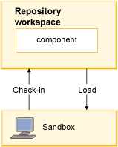

Figure 1

When you work as part of a team, your workspace and the workspaces of other team members are configured to deliver their changes to a shared repository object called a **Stream**.

[Figure 2](https://www.ibm.com/support/knowledgecenter/en/SS2L6K_6.0.1/com.ibm.team.scm.doc/topics/c_getting_started.html?view=kc" \l "c_getting_started__fig_ws-stream) shows how change sets are created in a Sandbox, checked-in to a Repository Workspace and then can be delivered to a stream, so that all team members use. Because the Stream is a **Flow** **Target** of all team members' repository workspaces, the Change Sets it contains are accessible to all team members.

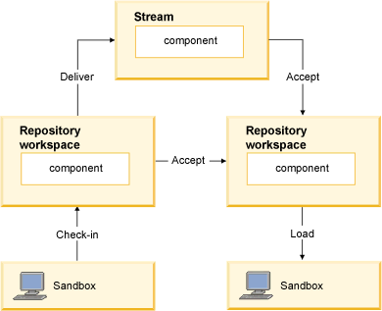

Figure 2

**Jazz SCM core operations**

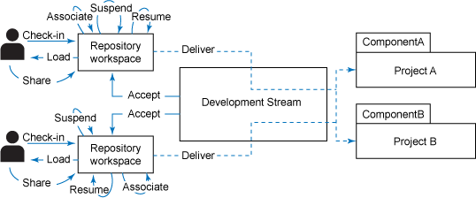

# 

**Checking in changes:** When users check in their changes, they essentially package changes from a local workspace and copy them to a change set that is stored in a repository workspace.

**Share:** Taking an existing Eclipse project or Visual Studio solution and sharing it to Jazz SCM for configuration management purposes.

**Deliver:** This operation shares the change sets to Stream.The change set is marked as complete if not already completed and then flows to the current Flow Target of the Workspace.

**Discard:** The Change Set is discarded and the items in it revert to the state they were in before the first change was made. This operation permanently undoes all the changes in the Change Set.

**Promote:** The act of promoting means that you are moving the storage location of a snapshot from where it resides to another repository workspace or stream.

**Associate:** When you associate change sets, you create a relationship between the change sets and either Rational Team Concert work items or OSLC change sets.

**Lock:** This operation locks a specified asset within the context of the stream, which prevents other users from modifying the stream. The user that initiated the lock operation of that stream can still modify it.

**Unlock:** This operation restores the ability of users to modify a locked asset.

**Suspend:** This operation is used on a change set that is stored in a repository workspace. The repository workspace configuration is modified so that it does not include the change set. The local workspace that is associated with the repository workspace is updated immediately to ensure the change set is not included. The change set is still stored within the repository workspace and can be resumed at any time.

**Resume:**This operation is used on a suspended change set that is in a repository workspace. The repository workspace configuration is updated to include the resumed change set. At this point, the local workspace might have to accept the change set and perform a merge with any changes made since it was suspended.

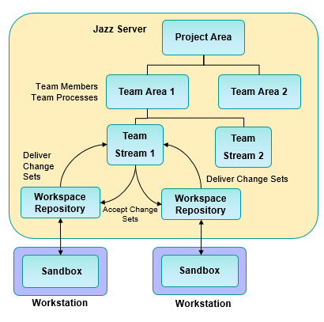

* The **project area** is the top level of project organisation
* The project area contains one or many **team areas**
* Team areas have one or many **streams** of development activity contained in them
* **Workspaces** are the users sandbox used to perform work. They are replicated between the Server (Repository Workspace) and Workstations **Sandbox**.
* Changes are checked into a **change set**. The change set records the before and after states of each file. Content is stored separately and is delta-compressed
* You **Check-in** changes from the Sandbox to the Repository Workspace. This also places the changes in a change set
* You **deliver** change sets from Repository Workspace to Team Stream
* You **accept** change sets from the team stream into your workspace and hence your Sandbox

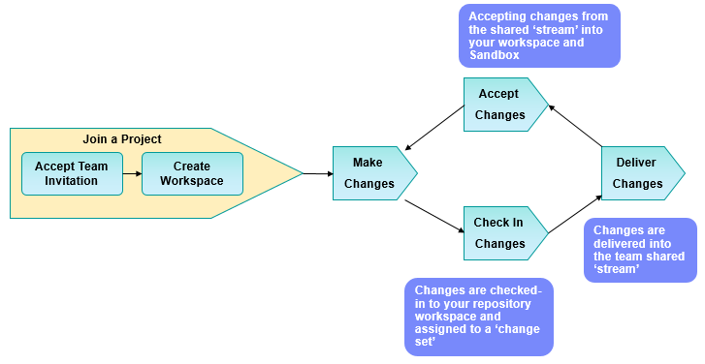

**Default Streams and Components:**

When the project is set-up in RTC, a default Stream and a default component in the Stream is created. Initially, there is no source code in the Stream as shown below.

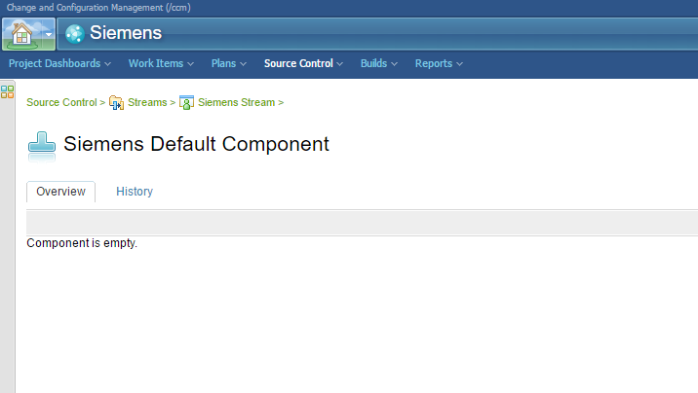

**Accepting Team Invitation:**

Open Eclipse Client and it looks like below.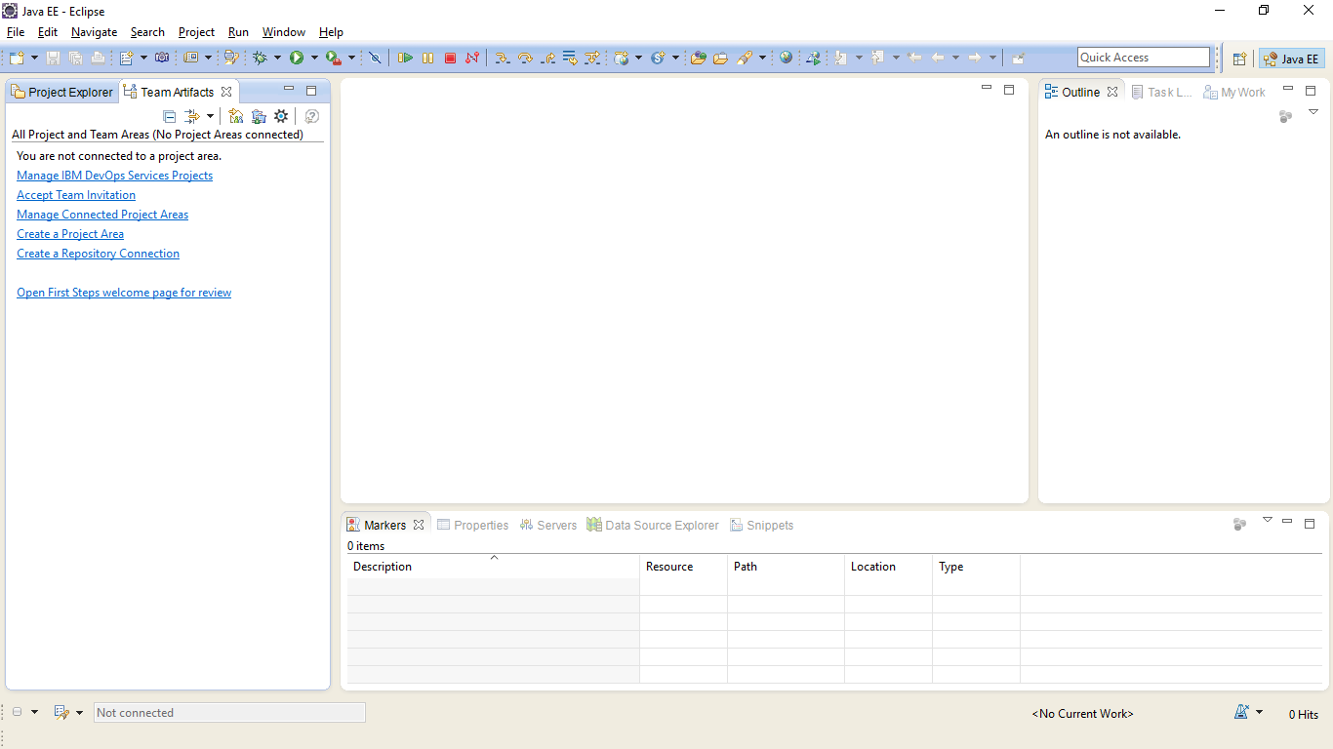

A Perspective is a collection of views to enable the user to perform tasks in Eclipse. For example, the Work Item Perspective is the main perspective for performing RTC tasks. The Java Perspective is used for Java development.

A Perspective is a collection of views to enable the user to perform tasks in Eclipse. For example, the Work Item Perspective is the main perspective for performing RTC tasks. The Java Perspective is used for Java development.

To Open Java Perspective, Click on **Window>Open Perspective>Java** 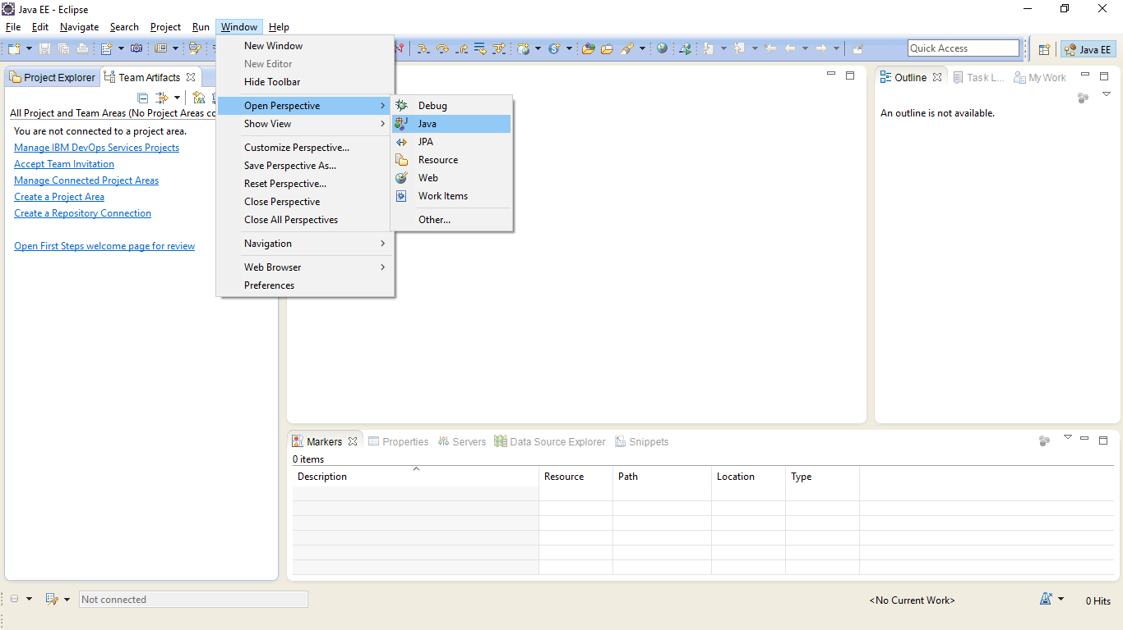

My Work, Team artifacts and Team DashBoard views will be displayed as shown below.

The “Team Artifacts” view will only look like this the first time you access it.

Click on Accept Team Invitation in the Team Artifacts view.

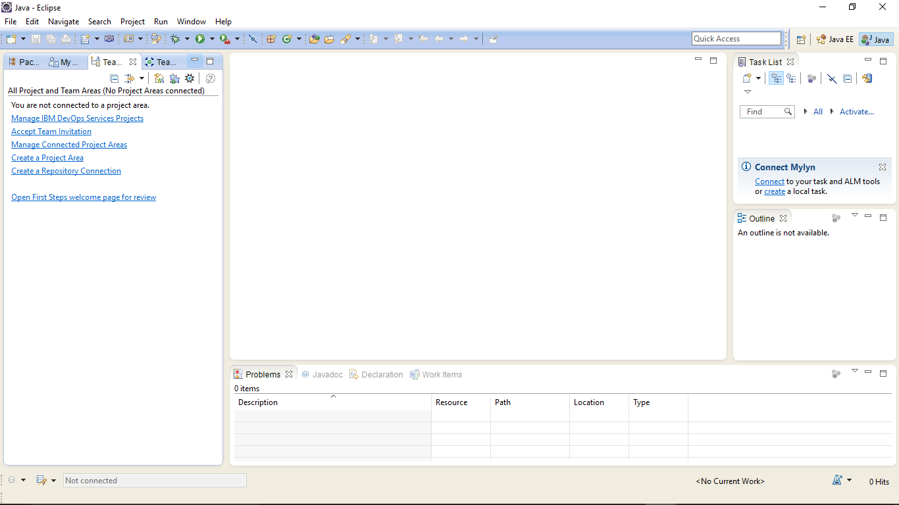

The “Accept Team Invitation” window will now be displayed

You will receive a Team Invitation email when you are added as a member to a project area, that contains the URL for the RTC web client and the repository information for the Eclipse client.

“Copy” and “Paste” the Repository Connection information from the team invitation Email into this area

After you have pasted the connection information into the window, click on “Finish”

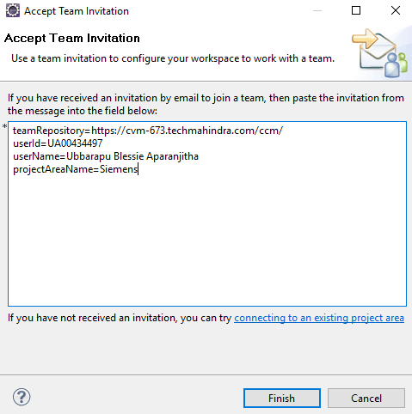

The “Log in Required” window will now be displayed. Enter your password and check the “Save Password” and “Automatically Log in” check boxes. Then press the “OK” button.

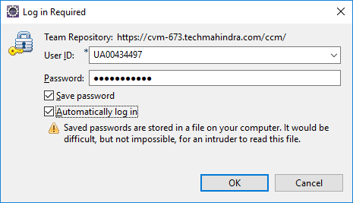

The Team Artifacts view will now be displayed showing you the new team connection. Project Area View. This contains configuration details of your project area.

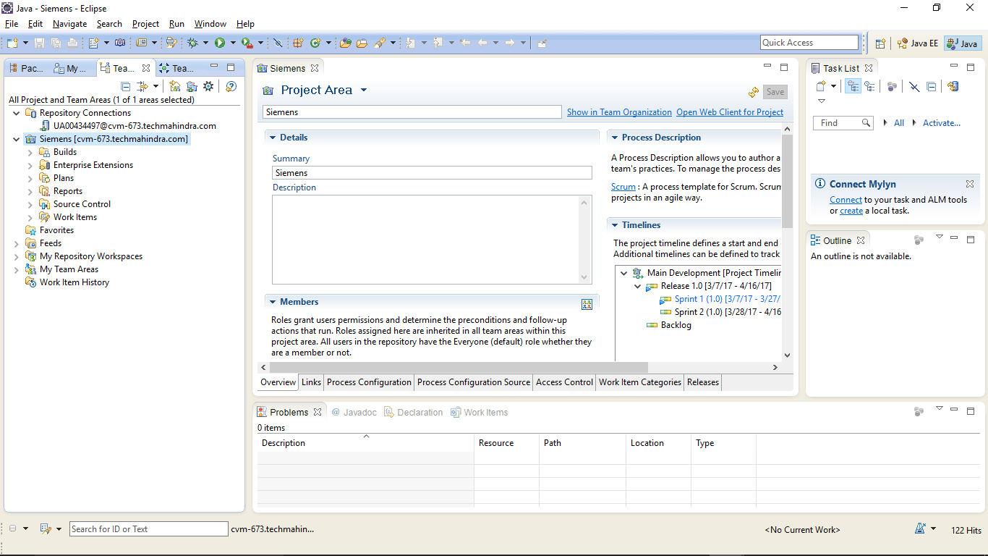

**Creating a Repository Workspace:**

Expand “Source Control” and right click on the Stream that you want to join. Then Click on **New>Repository Workspace.**

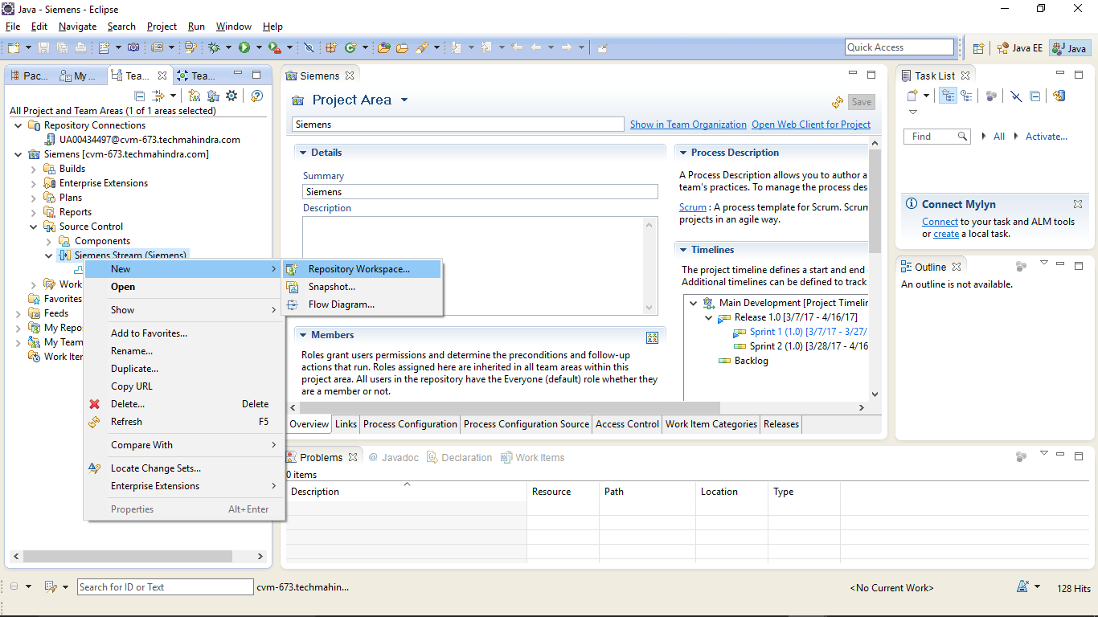

The “New Repository Workspace” windows will be displayed.

Provide a unique repository name and click on **Next** to continue to the next step.

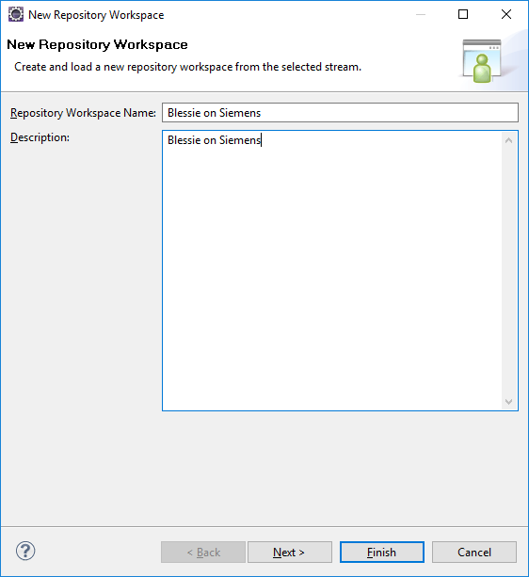

Select the “Use Current Repository” radio button and press **Next**.

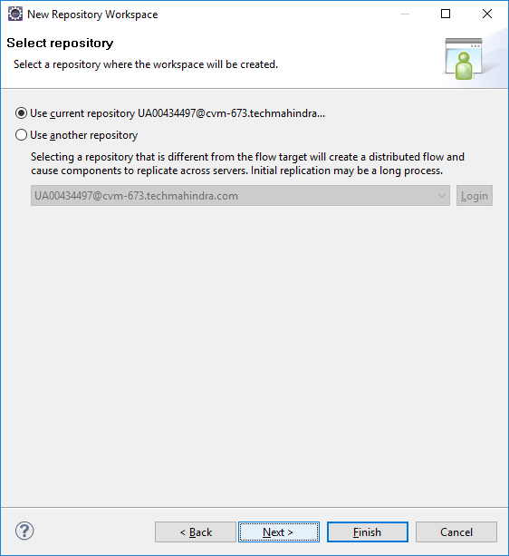

Select the “Scoped” radio button and select the project you are joining.

Click on **Next**

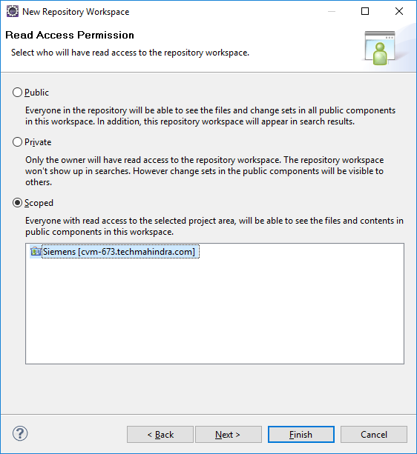

Select the components in the Stream that you wish to load into your workspace. There may be one or many components available to select.

Press “Finish” to continue to the next step.

Ensure the “load repository” check box is selected so that the repository is loaded with the projects in the Component of a Stream.

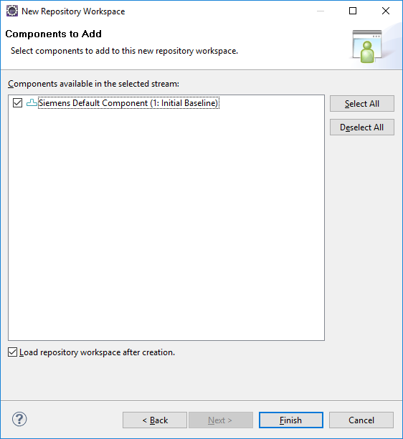

The “Load Repository Workspace” Window will then be displayed

Select “Find and load Eclipse projects” to load existing projects into your workspace

Press “Next” to continue to the next step

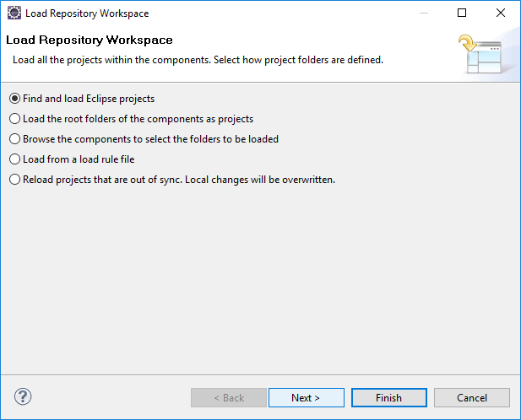

Select the Eclipse projects that you wish to load. There may be one or many projects available to select.

No projects are displayed as there are no projects in the Stream yet.

**Note**: From a performance point for view we recommend only loading only the minimum set of Eclipse projects into the workspace.   
  
If possible when working on multiple Eclipse projects create independent workspaces for each project.

Press “Finish” to start the loading of the workspace.

Loading finishes very quickly as there is no code in the Stream yet.

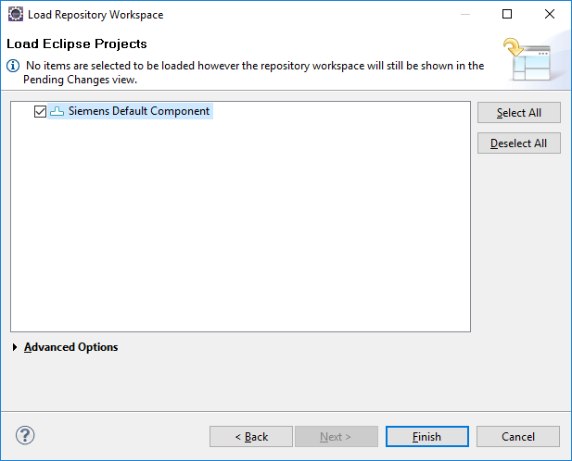

Your available workspaces are now shown in the Team Artifacts view under “My Repository Workspaces"

The Workspace you have just created appears in Pending Changes view.

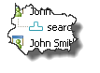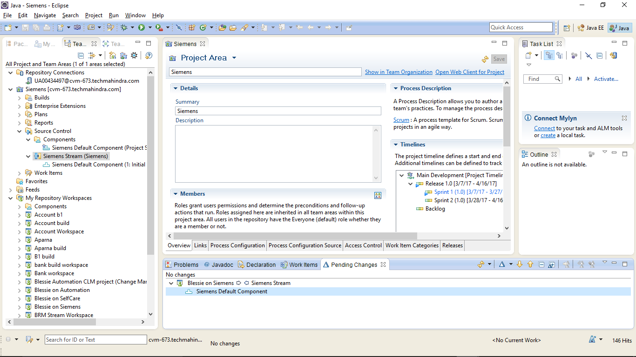

When a component looks like this it means it is not loaded in a workspace

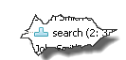

When a component looks like this it means it is loaded in a workspace

You can find the Work Items assigned to you in “My Work” View.

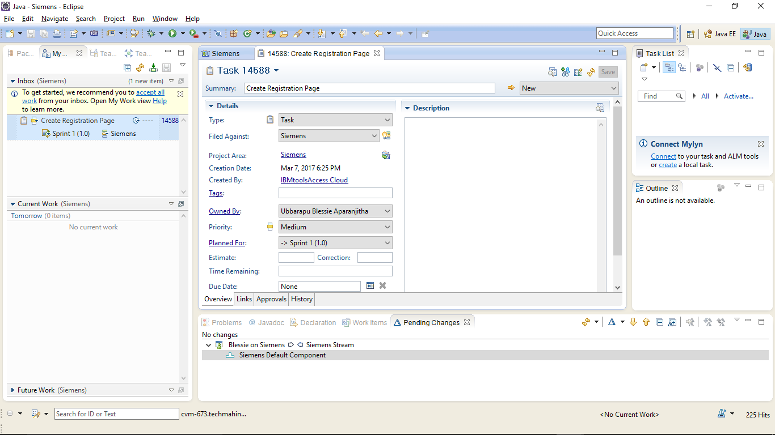

Double click on the Work Item to open it in editor.

Start working on the Work Item by changing it’s status to Start Working. The State will be changed to In Progress.

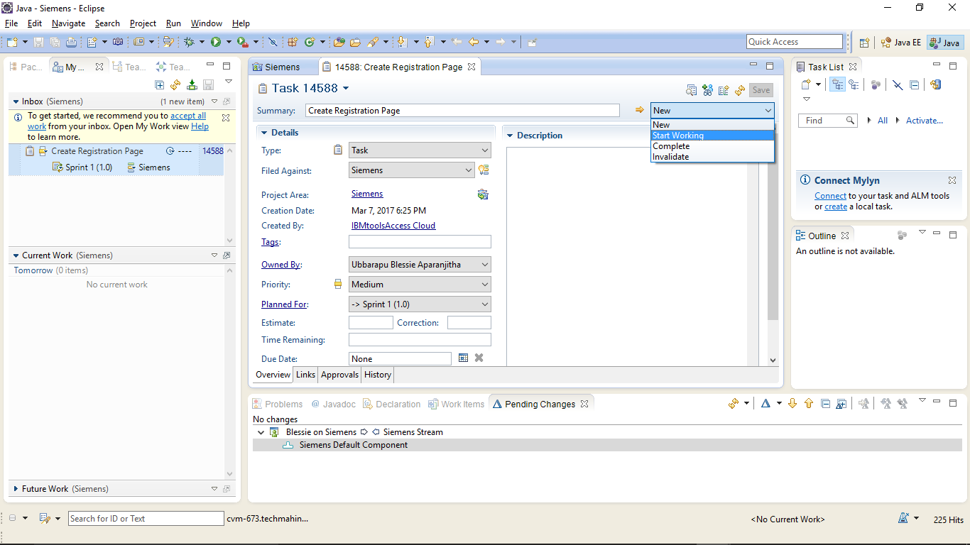

**Share the Project with Jazz Source Control:**

Right click on the Project and select **Team>Share Project**

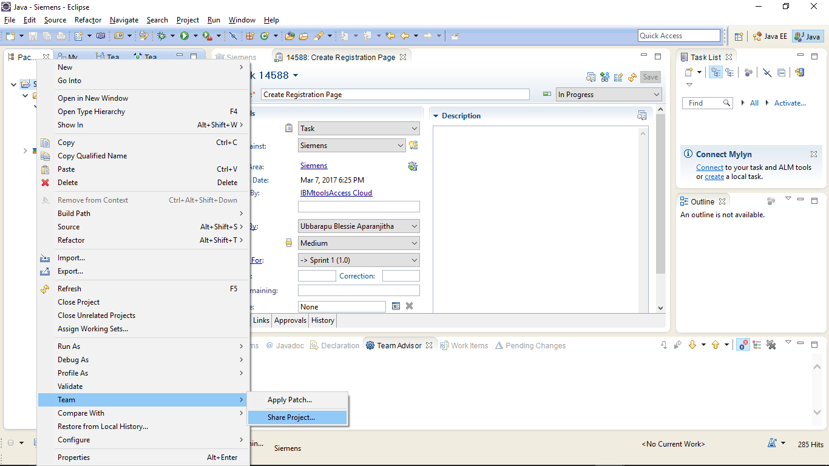

Select Component windows is displayed.

Select the Component to which you want to share the project or you can create a new component..

Click on **Next.**

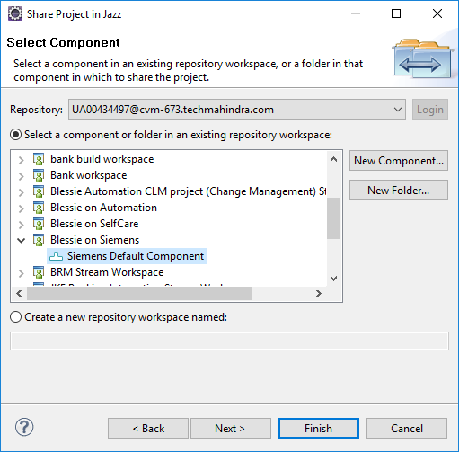

Project window is displayed.

Select the projects which you want to share with the Jazz Source Control.

Click on **Next.**

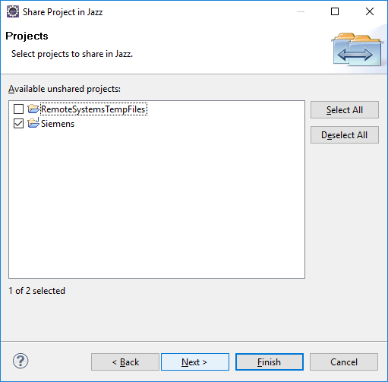

Verify that the resources you want to share are not ignored and click on **Finish.**

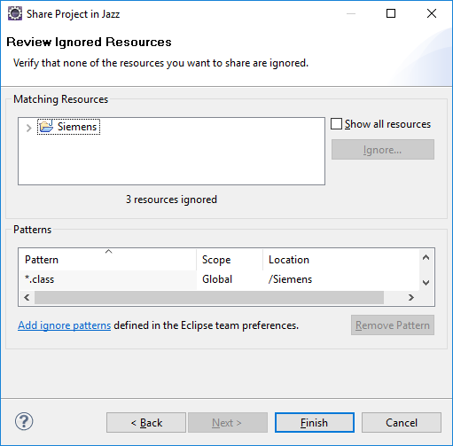

The project you are trying to share is displayed in Pending Changes view Under Outgoing Folder.

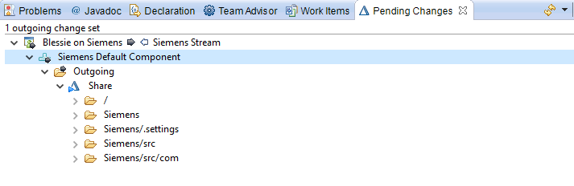

Right click on the Change Set and select **Related Artifacts>Associate Work Item** to associate a work item you are working on to the Change Set.

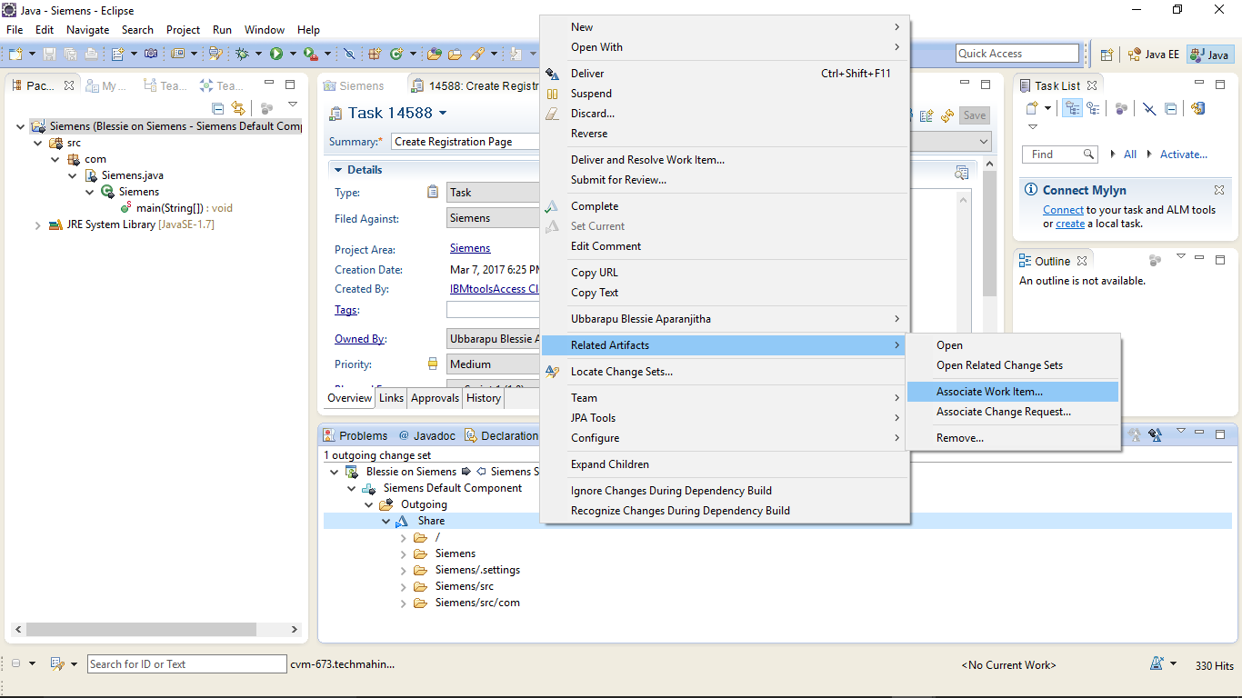

The List of Work Items that are in the In Progress state will be displayed.

Select a Work Item and click on **OK.**

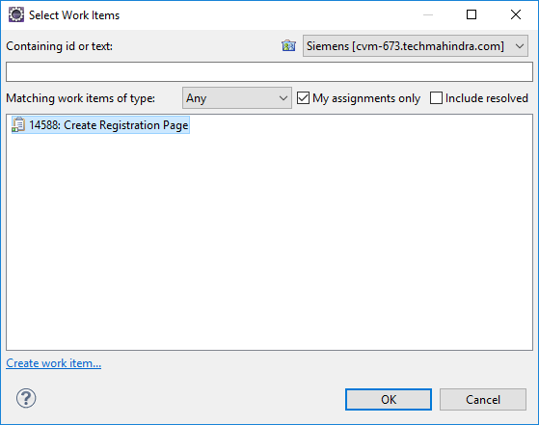

You can see that the Work Item is associated with the Change Set.



It is important to give change sets a useful comment so that they can be easily identified.

Right click on the Change Set and select “Edit Comment”

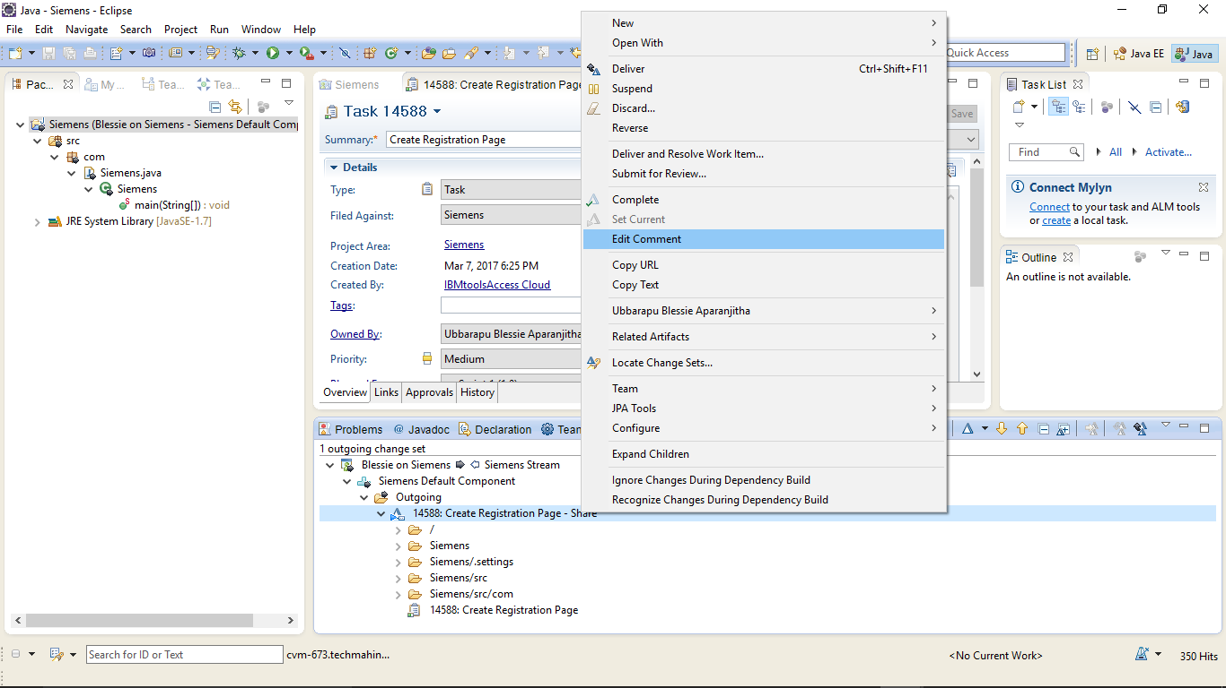

Add a comment and Click on **OK.**

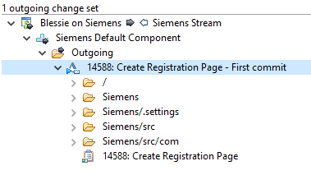

**Deliver the source code to Stream and Resolve the Work Item:**

Right click on the Change Set and select “Deliver and Resolve the Work Item”, to share the code to the Stream and resolve the Work Item.

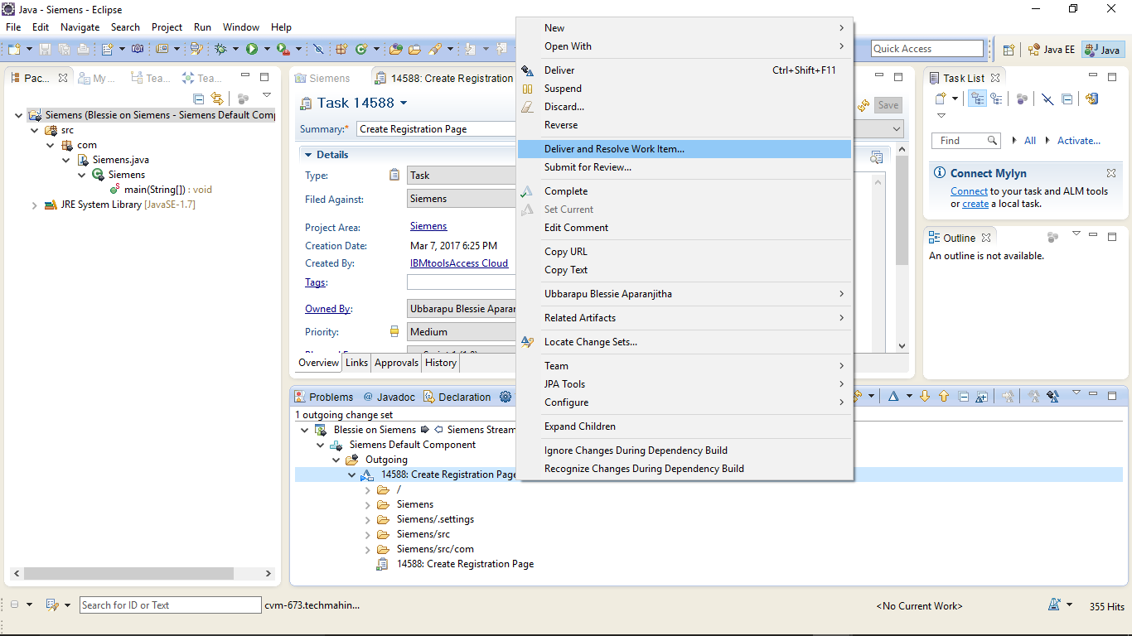

Deliver and Resolve window will be displayed. Add a comment and click on **Finish.**

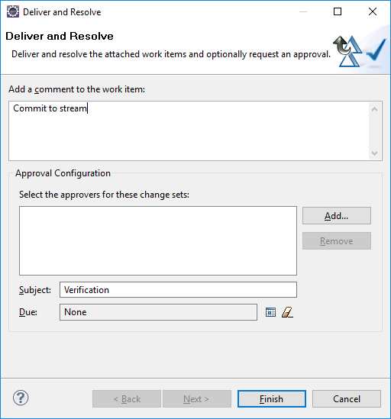

Login to RTC Server Web UI to check the Source code that has been shared.

Open the Project Area, select **Source Control>Streams.**

Select the Stream and then select the Component.

The Project you have shared will be displayed something like below.

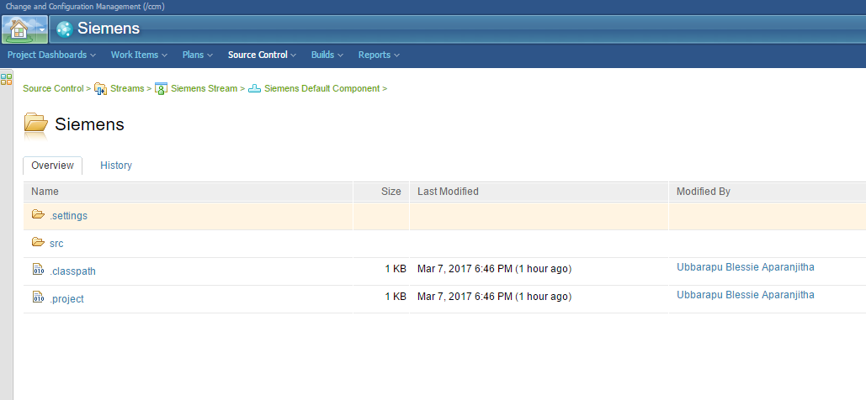

Now, the source code is in the Component of a Stream.

Any of the Team Members can login and access the code. They can add new features or modify the existing code.

**Accepting the Changes:**

When another member of the same project needs to access the code that is present in the Stream, he may follow the below steps.

Create a Repository workspace in the Stream as described earlier.

Expand Source Control, Right Click on the Stream and click on **New>Repository Workspace.**

New Repository Workspace window will be displayed.

Provide a unique name and click on **Next.**

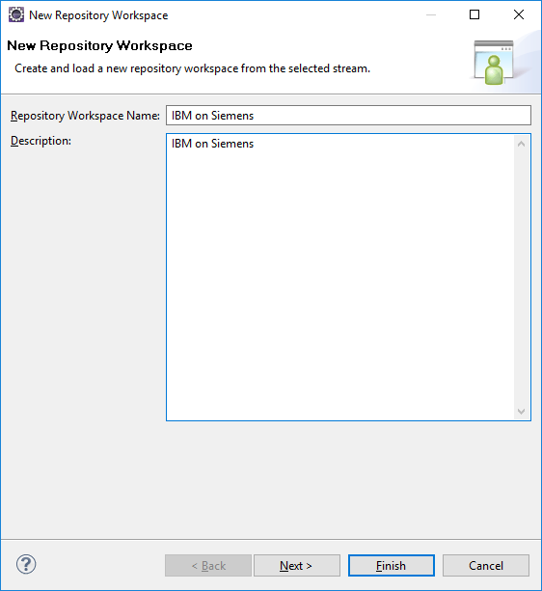

Select the “Use Current Repository” radio button

Press “Next”

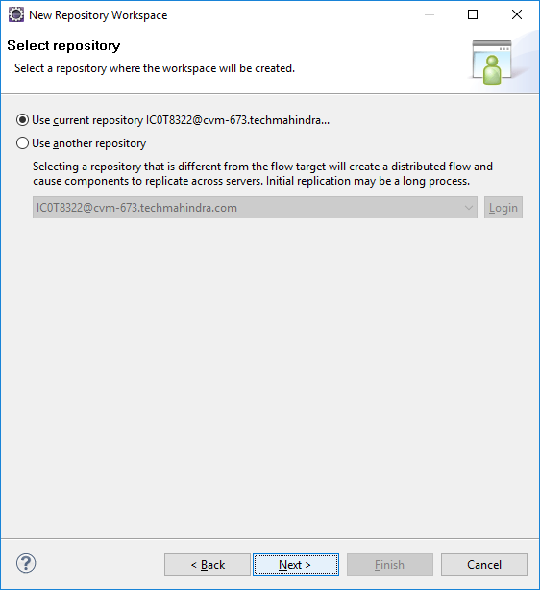

Select the “Scoped” radio button

Select the Project you are joining and press “Next”

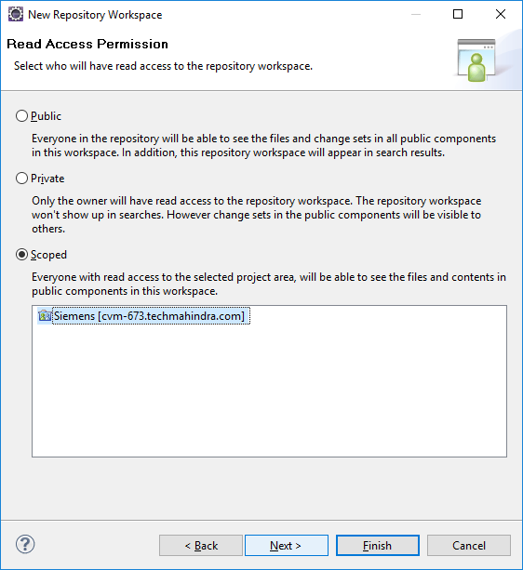

Select the components in the Stream that you wish to load. There may be one or many components available to select.

Ensure the load repository check box is selected so that the repository is loaded

Press “Finish” to continue to the next step

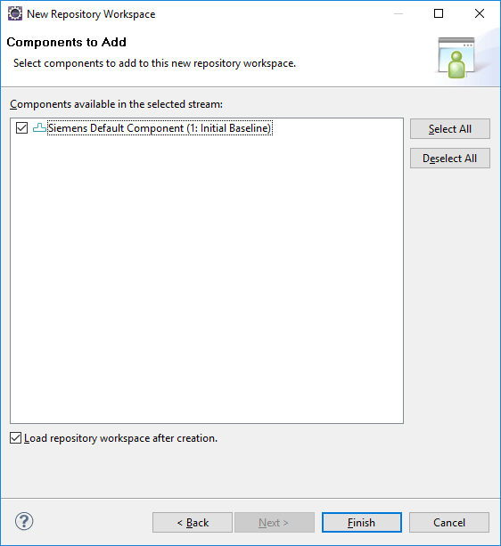

The “Load Repository Workspace” Window will then be displayed

Select “Find and load Eclipse projects” to load existing projects into your workspace

Press “Next” to continue to the next step

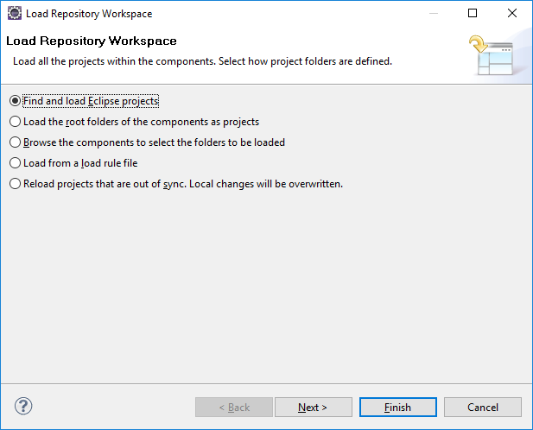

Select the Eclipse projects that you wish to load. There may be one or many projects available to select.

The Project that has been shared in the previous section will be listed here.

Select the project and Press “Finish” to start the loading of the workspace.

Note: From a performance point for view we recommend only loading only the minimum set of Eclipse projects into the workspace.   
  
If possible when working on multiple Eclipse projects create independent workspaces for each project.

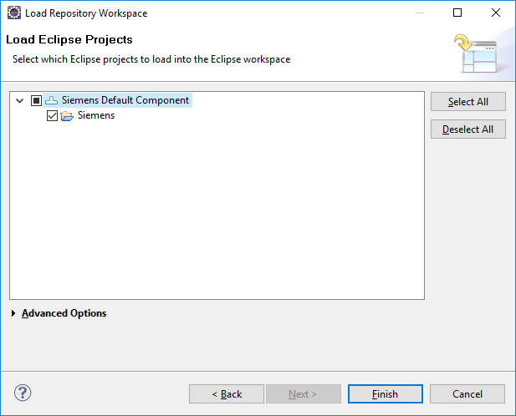

The “Loading Repository Items” windows will be displayed as your local repository is loaded.

Depending on the size of the workspace you are loading and the speed of the network connection, this may take a while.

The project that has been loaded can be viewed in the Package Explorer View.

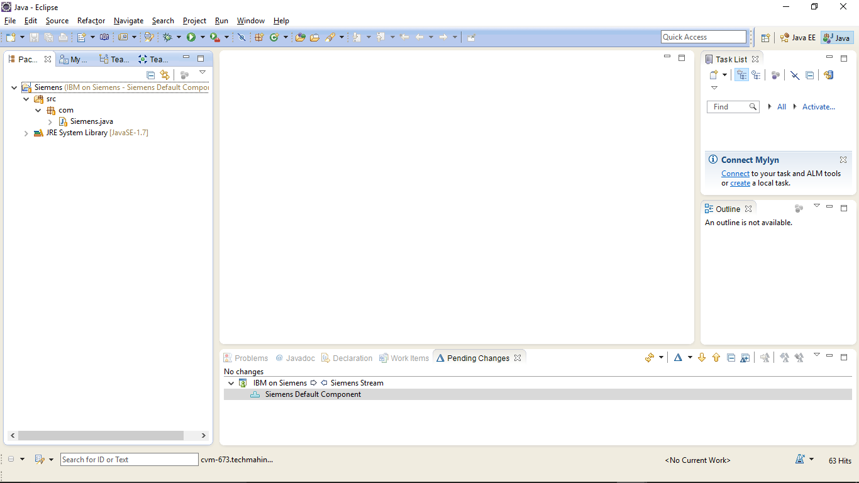

From My Work view, select the work item that you wish to work on and change it’s status to Start Working.

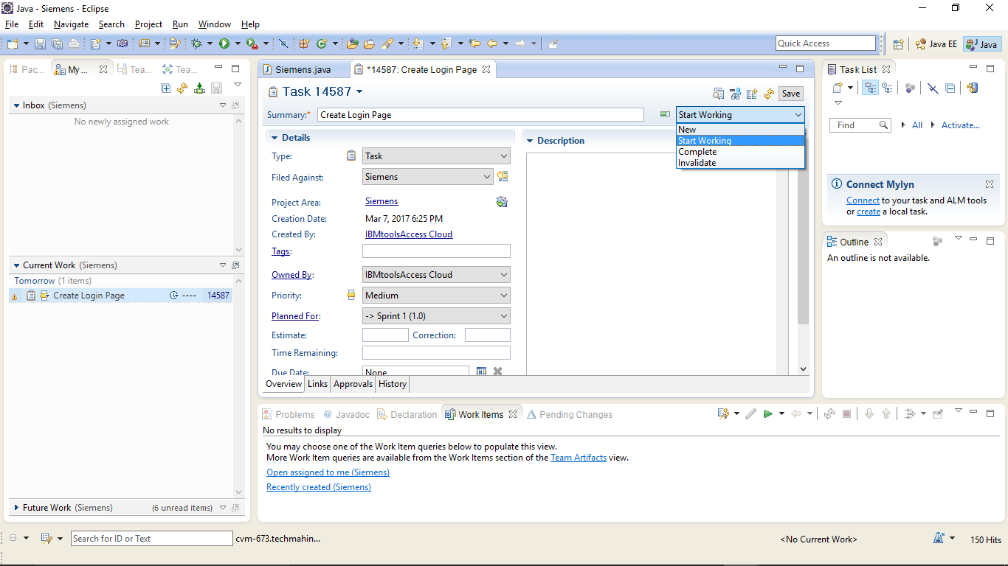

Open the files you wish to modify and make the changes. When you save the changes, they will be accumulated under the Unresolved folder of component in Pending Changes view.

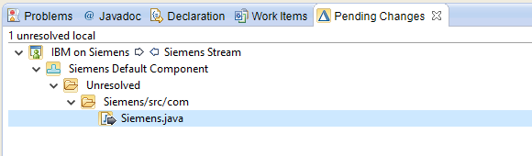

Right click on the unresolved folder and select Check-in All.

If you wish to add the changes to a new Change Set, you can select **Check-in>New Change Set.**

This will update the Repository Workspace with the changes

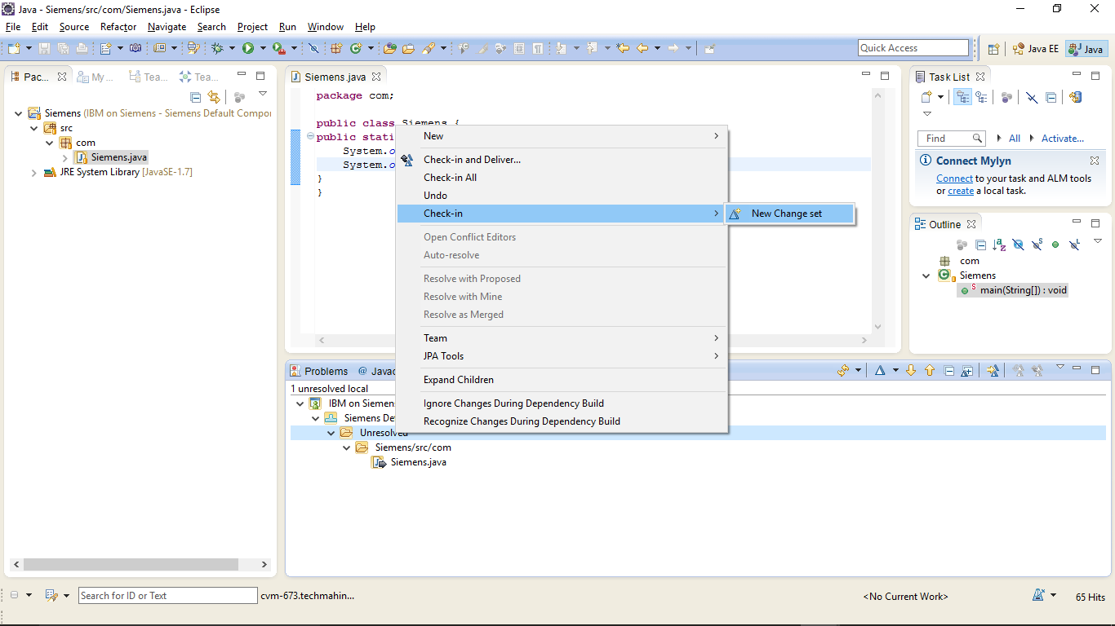

As soon as you check in the changes, they will be accumulated in a Change Set as shown below.

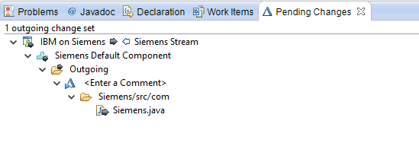

It is important to give change sets a useful comment so that they can be easily identified.

Right click on the Change Set.

Select “Edit Comment” and add a comment.

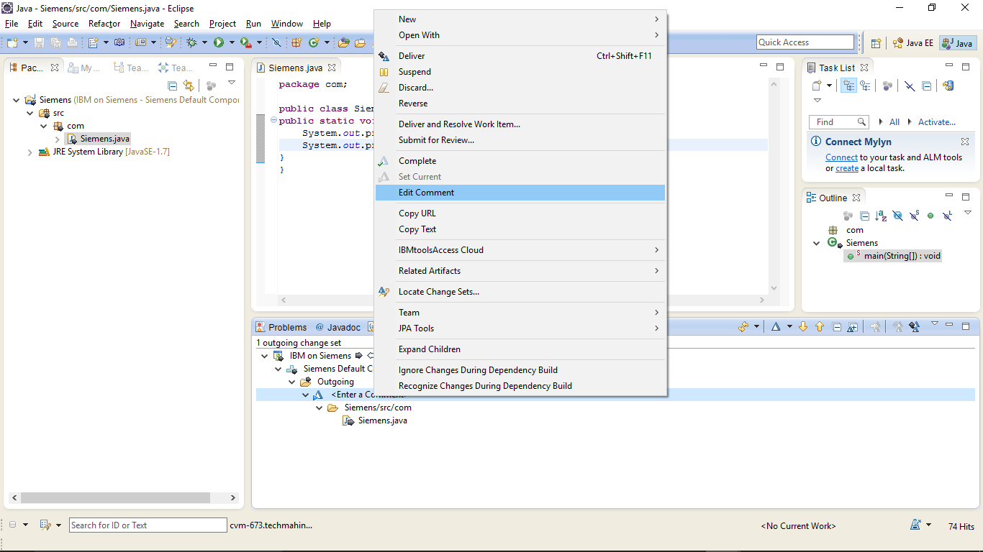

Associate a Work Item to the Change Set. Right click on the Change Set and select **Related Artifacts>Associate Work Item.**

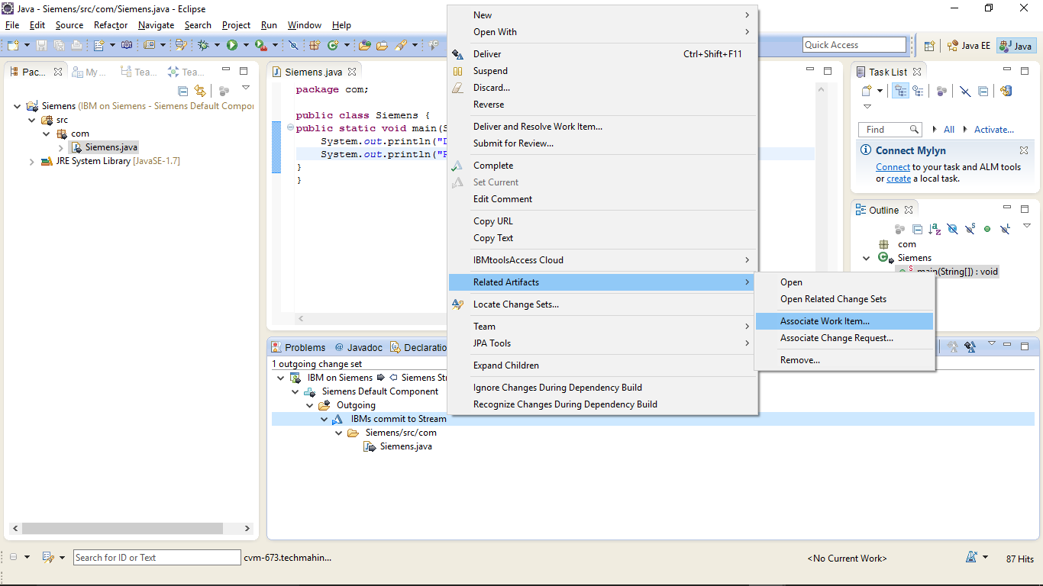

Select Work Items window will be displayed.

Select a work item and click on **OK.**

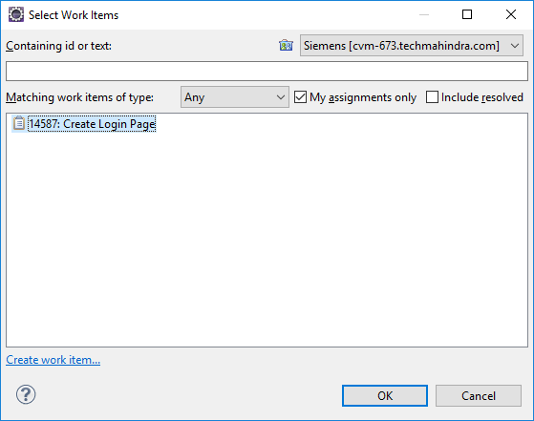

Right click on the Work Item and select Deliver and Resolve Work Item.

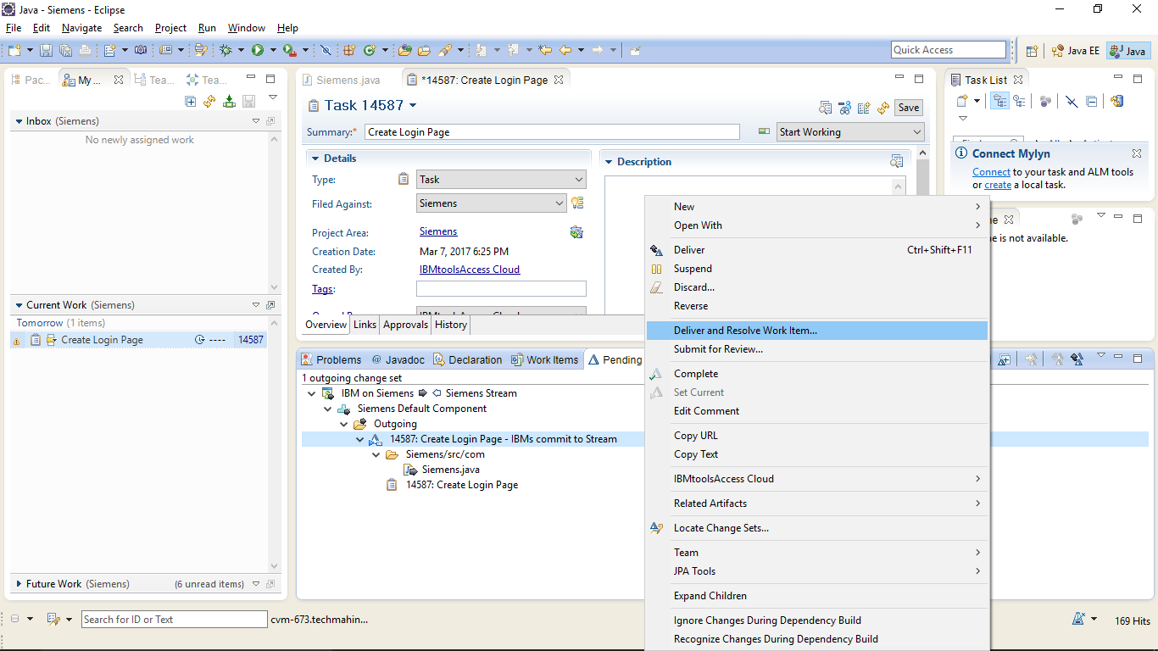

Add a comment and click on **Finish.**

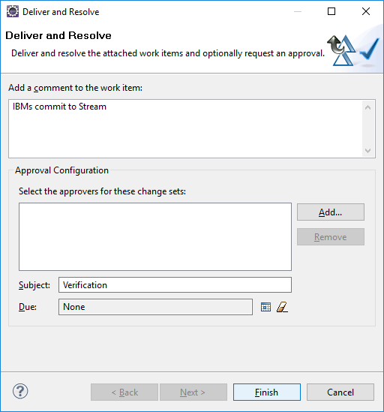

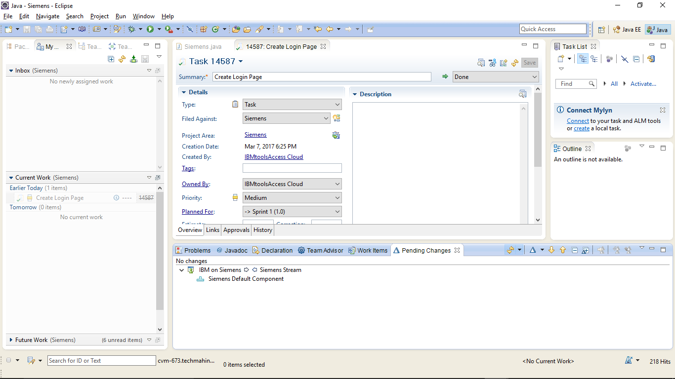

You can verify that the work item is moved to Done state.

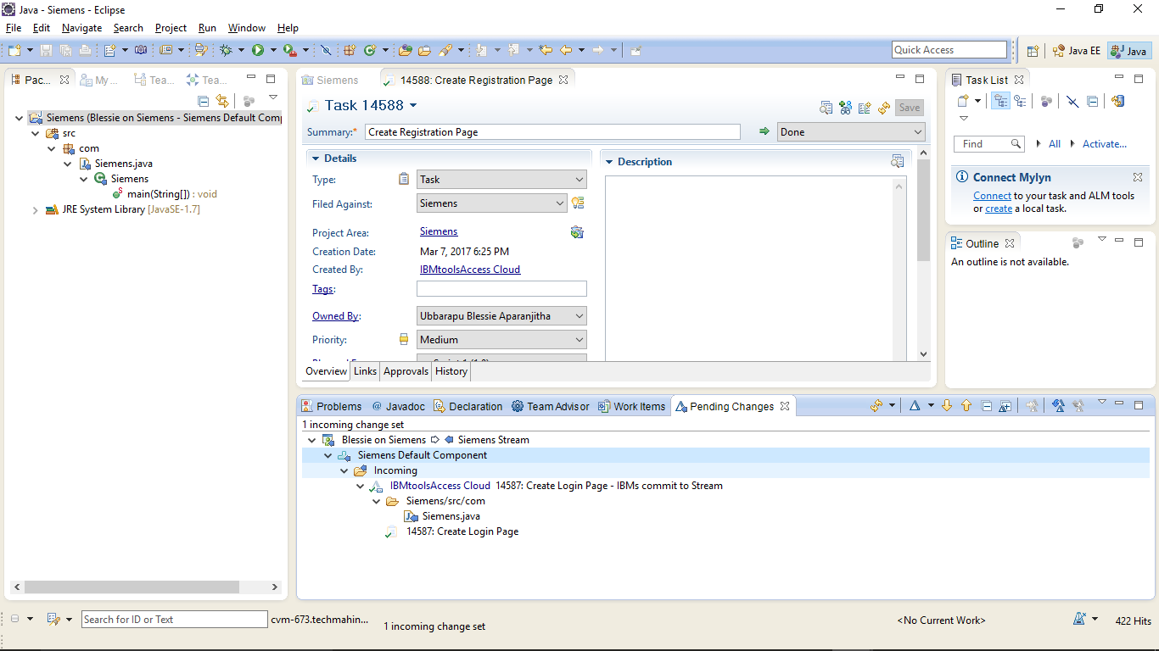

**Accept Incoming Changes:**

Other members of the team can view the changes under the Incoming folder of a component in Stream under Pending Changes view.

Right click on “Incoming” to accept all incoming change sets. Select ”Accept”

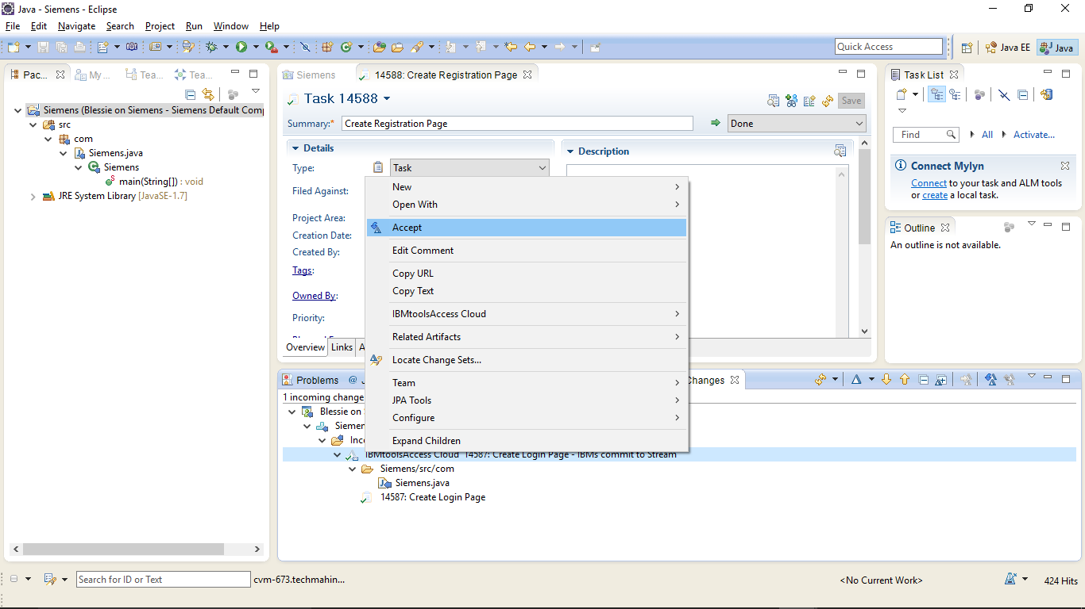

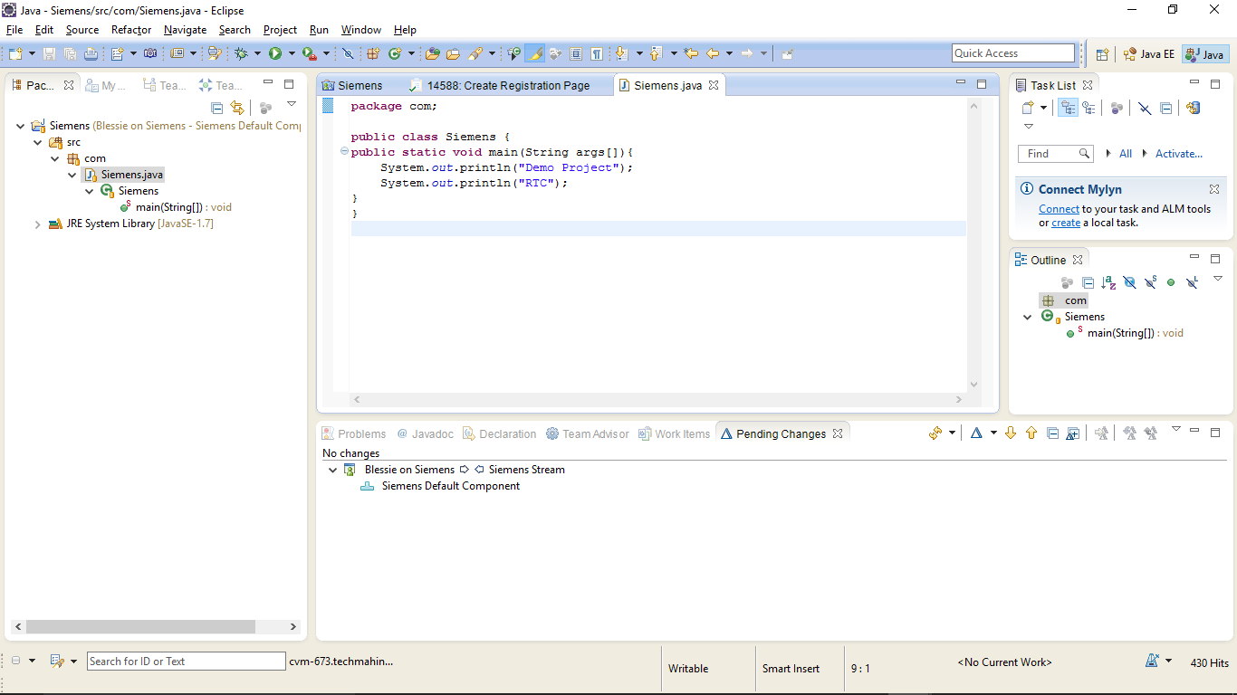

**Suspending and Resuming a Change Set:**

Suspending a change set enables you to suspend work on the current change set and resume the work later. Typically this could happen when a high priority task is assigned to you such as fixing a urgent defect.

Suspending removes the change set from the repository workspace and unloads it from the local work space but preserves it in the Stream.

**Suspend:**

Right click on the Change Set you wish to Suspend

Select “Suspend”

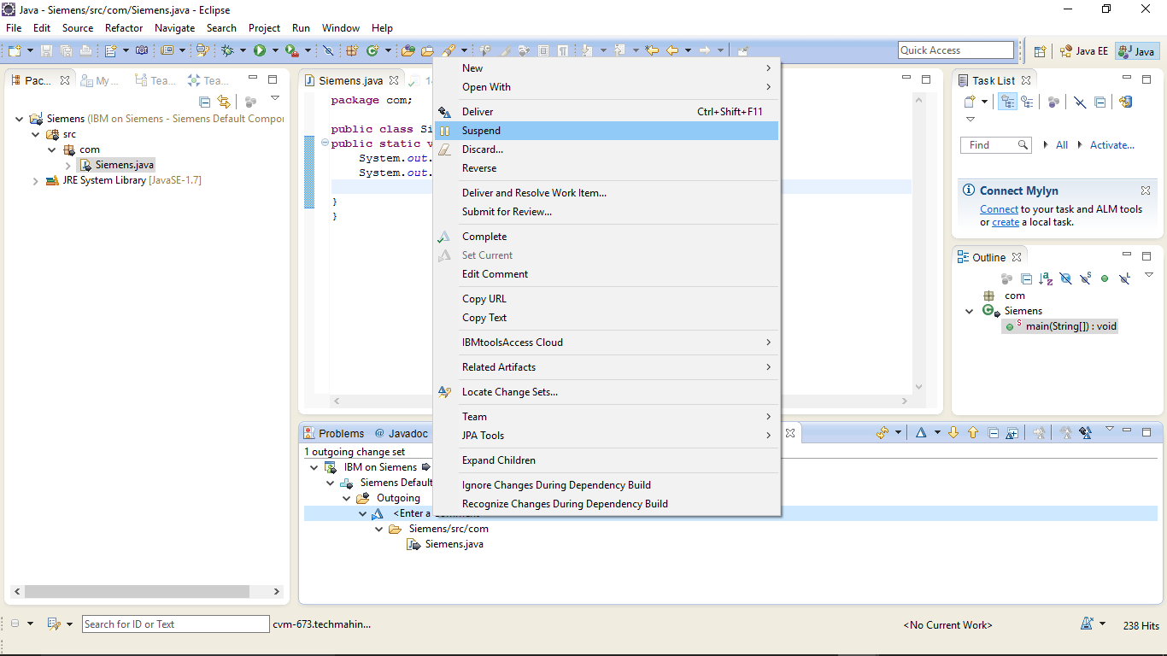

The change set will now appear in your list of suspended change sets

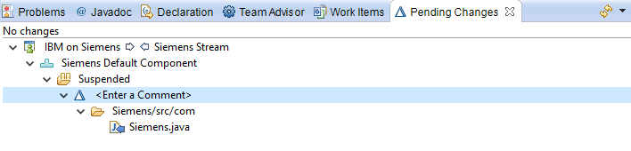

**Resume:**

To resume a suspended change set, Right Click on the Change Set you wish to resume

Select “Resume”

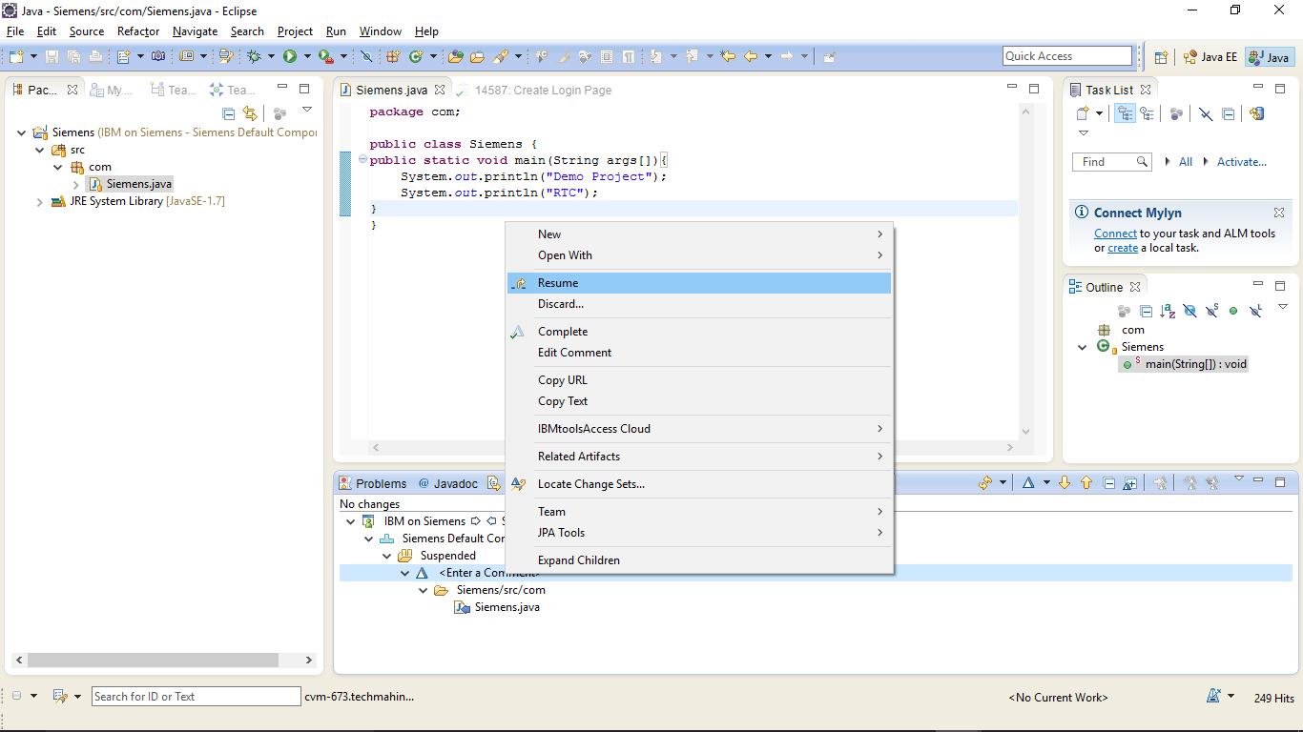

The Change set will be resumed.

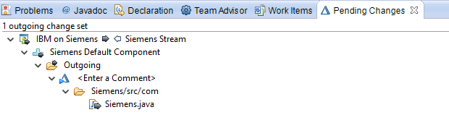

**Discarding and Completing a Change Set**

If you think that the change set is invalid or could cause problem to the project code, you can discard it. You can discard either a outgoing change set or an accepted change set.

Right click on the Change Set you wish to Discard

Select ”Discard”

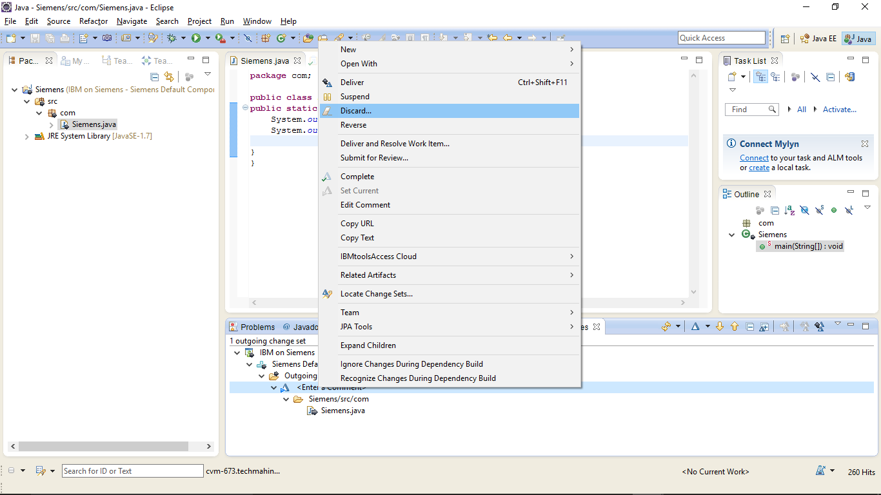

The Discarding Change Set Window will be displayed

Select ”OK” to discard the change set

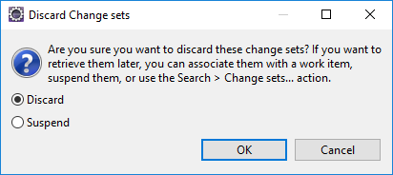

**Completing a Change Set:**

After you make all the changes to the change set, you can mark it complete. A change set marked complete is no longer active. You can not add new changes or remove any changes from it.

Right click on the Change Set you wish to Complete

Select ”Complete”

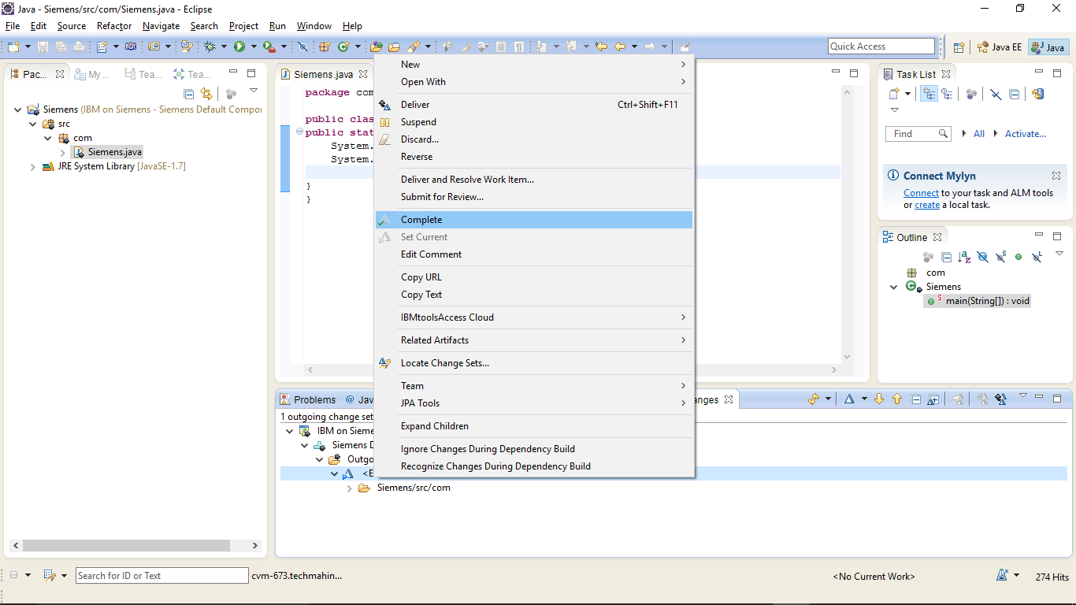

The Change Set will be marked as Complete.

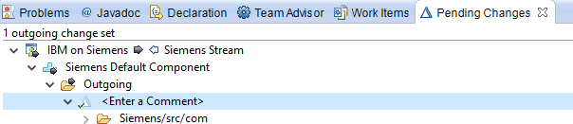

**Reversing a Change Set:**

Reversing a change set removes the changes captured in a change set. The reverse operation on a change set creates a patch. When you merge the patch into your workspace, the changes made to the selected change set are removed and a new change set is created. You can now deliver this change set to reverse the changes in the workspace flow target**.**

Right click on the Component containing the change set you wish to reverse

Select **Show>History**

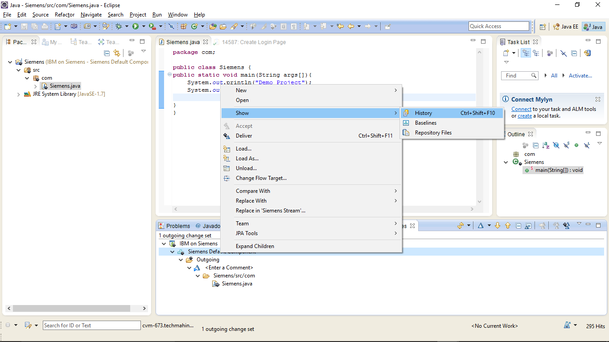

Right click on the change set you wish to reverse and select **Reverse.**

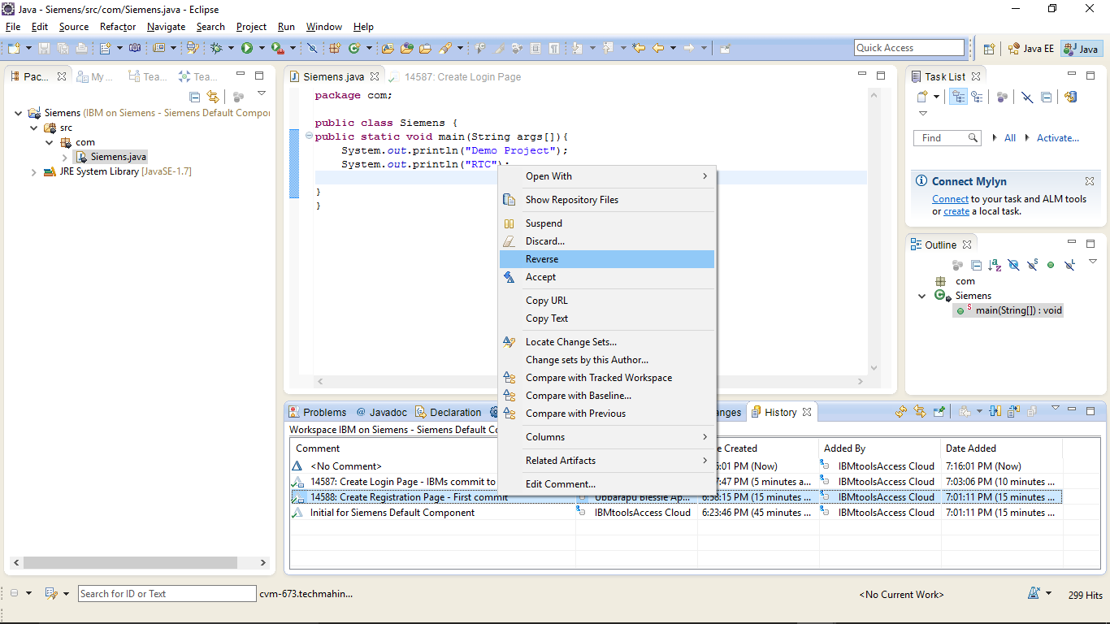

The “Patch Added to Pending Changes” window will be displayed. Press “OK”

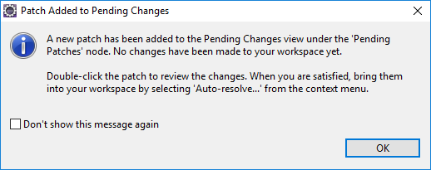

**Note**: You should complete or suspend any open change sets before merging

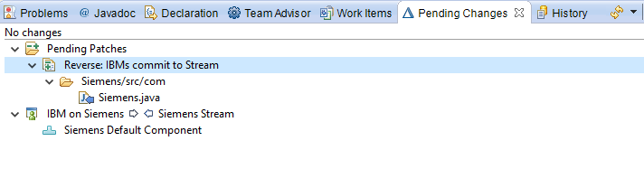

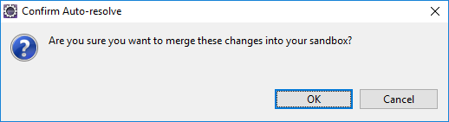

Click on **OK** to merge the changes into your Sandbox.

Finally you will need to Check-in and deliver the change set the merge has created

**Conflicts and Merging**

Conflicts arise when two or more team members modify the same file or folder. Conflicts can also arise when you suspend a change set, modify a file it contains, and then resume the change set.

In this case, you have accepted a change set that has caused a conflict. The conflict is displayed in the “Pending Changes” view.

 In Rational Team Concert this icon indicates a conflict

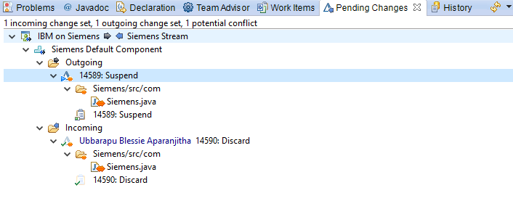

The first step is to open one of the conflicting files

Right click on one of the conflicting files

Select ”Open in Compare Editor”

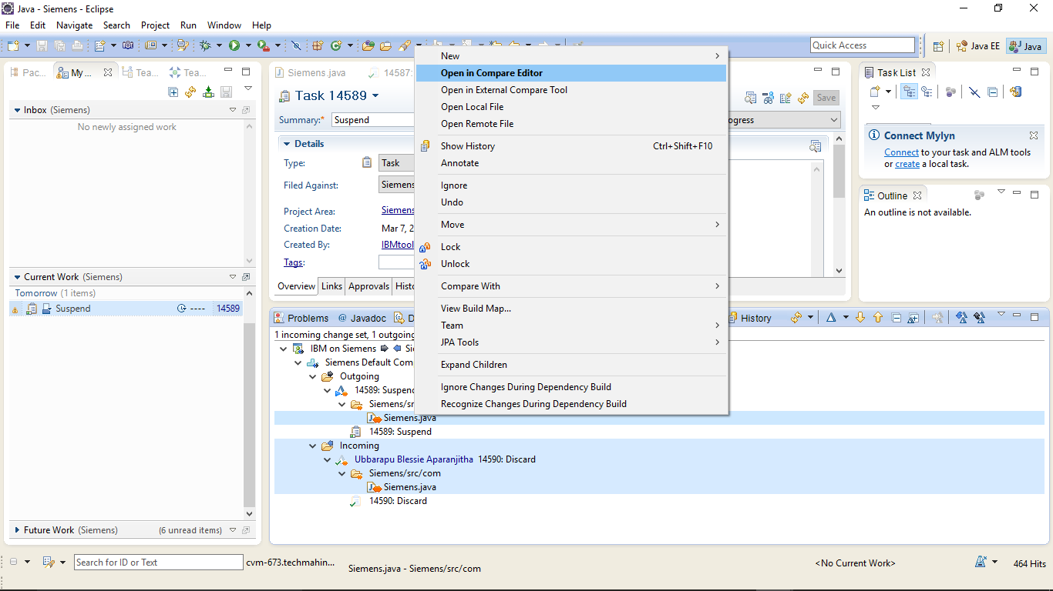

The Compare Editor will then open. The compare editor is based on the Eclipse compare editor

**Editor Navigation Buttons**

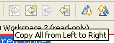 Copy All from Left to Right

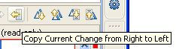 Copy Current change from Right to Left

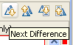 Next Difference

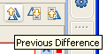 Previous Difference

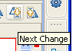 Next Change

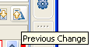 Previous Change

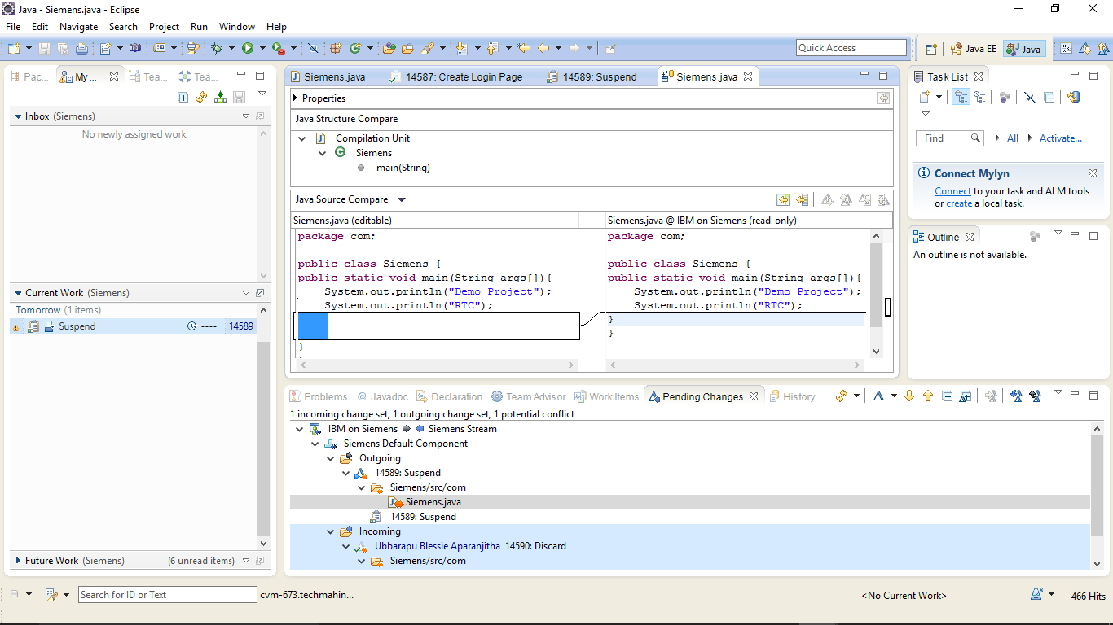

Select Copy All from Right to Left/Left to Right to resolve the conflicts.

Now try to accept the incoming change set and deliver the outgoing change set.

Auto-resolve Conflicts window will appear.

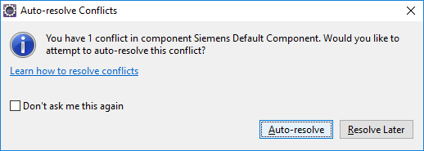

Select Auto-resolve.

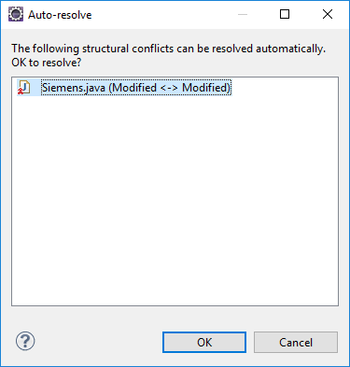

Click **OK.**

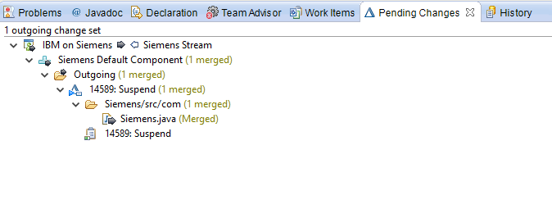

Change sets will be merged.

Completing the merge will result in a merged change set being generated. It is shown in the Pending Changes view. You will need to deliver this change set to complete the merge

**Creating Baslines:**

A baseline records the current configuration of a component in a repository workspace or stream. They enable you to revert to a previous component configuration or compare two configurations

Right click on the Component in your workspace that you wish to make a baseline on

Click on “Baseline”

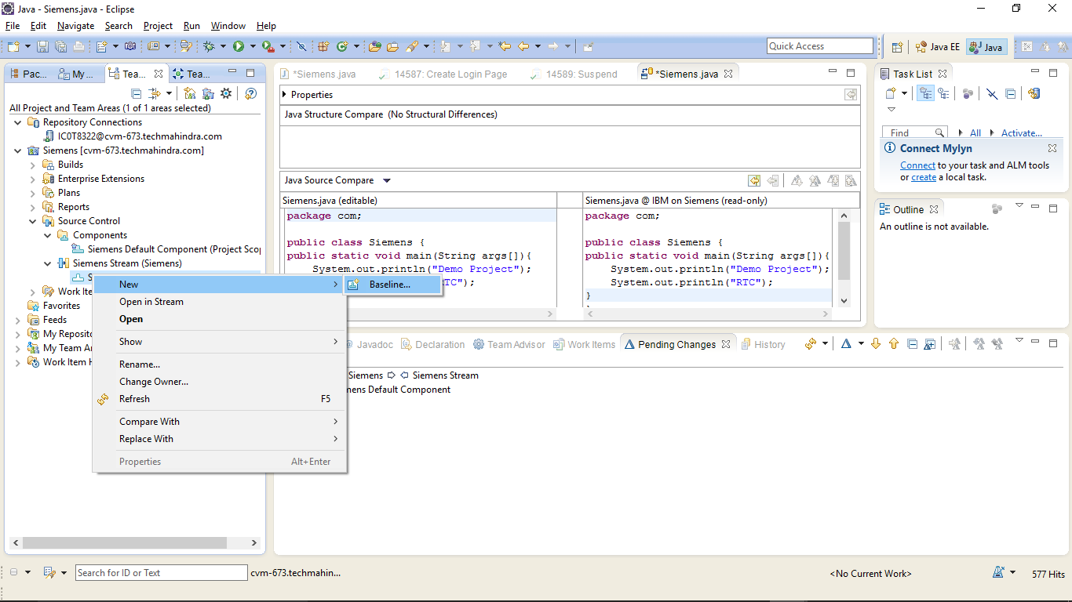

Enter a baseline name

Press “OK” to create the baseline

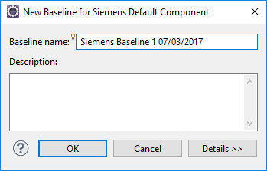

**Note**: It is important for projects to have good naming standards in place for baselines

The baseline will now appear as a outgoing change in the pending changes view. You will need to deliver this change to the stream

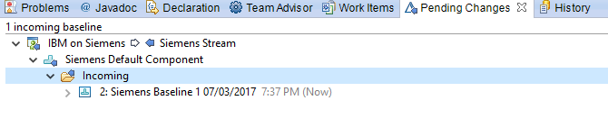

**Note**: It is good practice to create baselines frequently so you can easily go back to earlier configurations

To Go back to earlier configurations, you can replace the current baseline with previous basline version.

Right click on the Baseline that you wish to replace with a previous Baseline

Select **Replace With>Baseline**

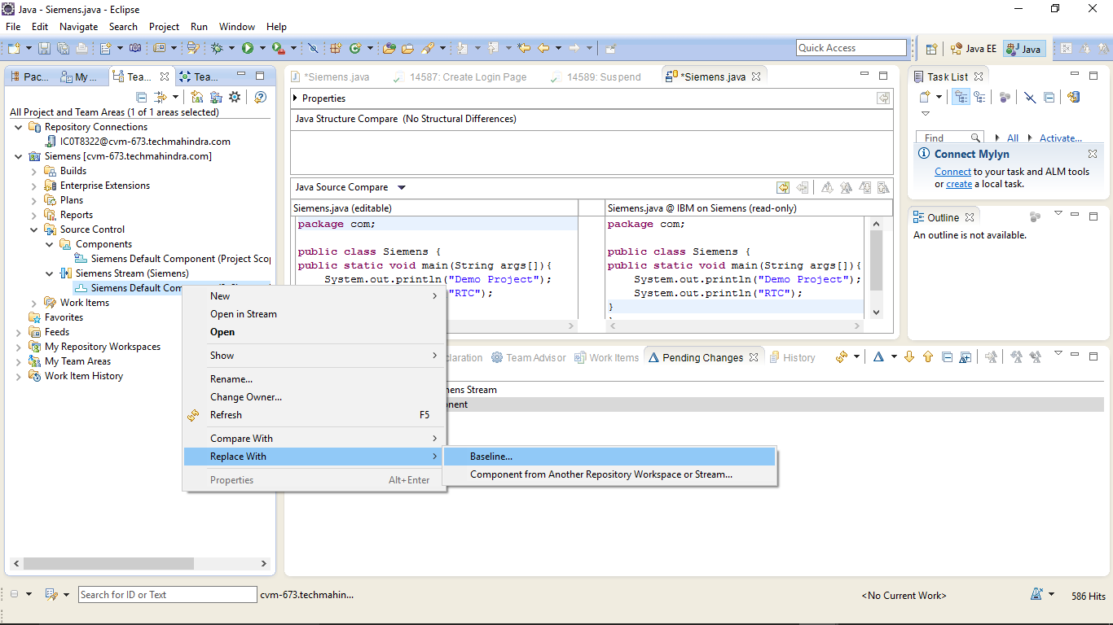

Select a Baseline from the list of Baselines available and click **Finish.**

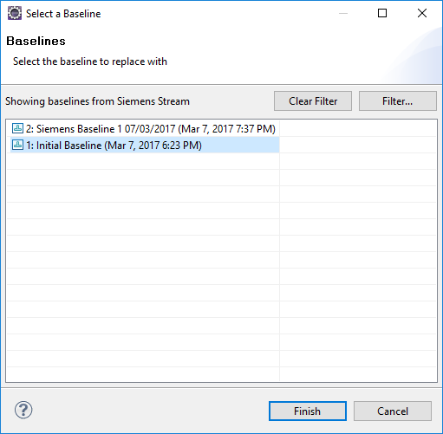

**Viewing History of a File or Folder**

Right click on the file or folder that you wish to display the history

Select “Team-> Show History” to open the History View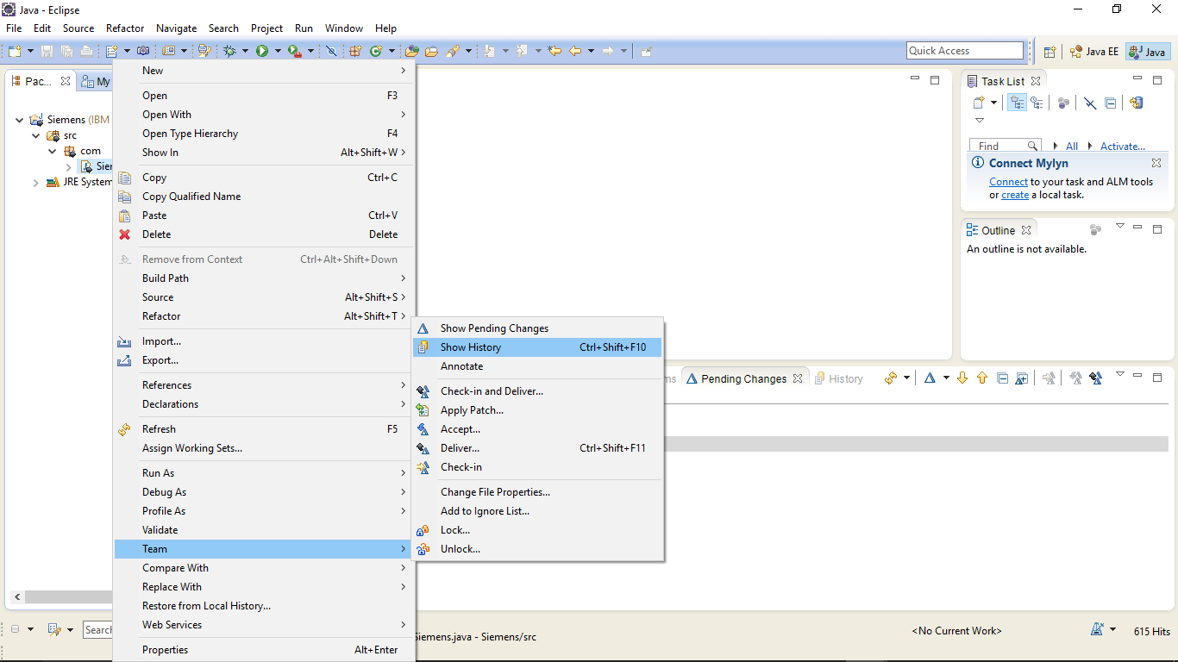

The History view is now displayed for the selected file or folder

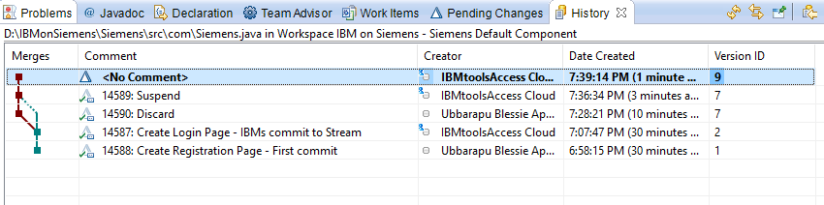

**Comparing versions of Files or Folders**

Right click on the version of the file or folder you wish to compare

Select “Compare with Previous”

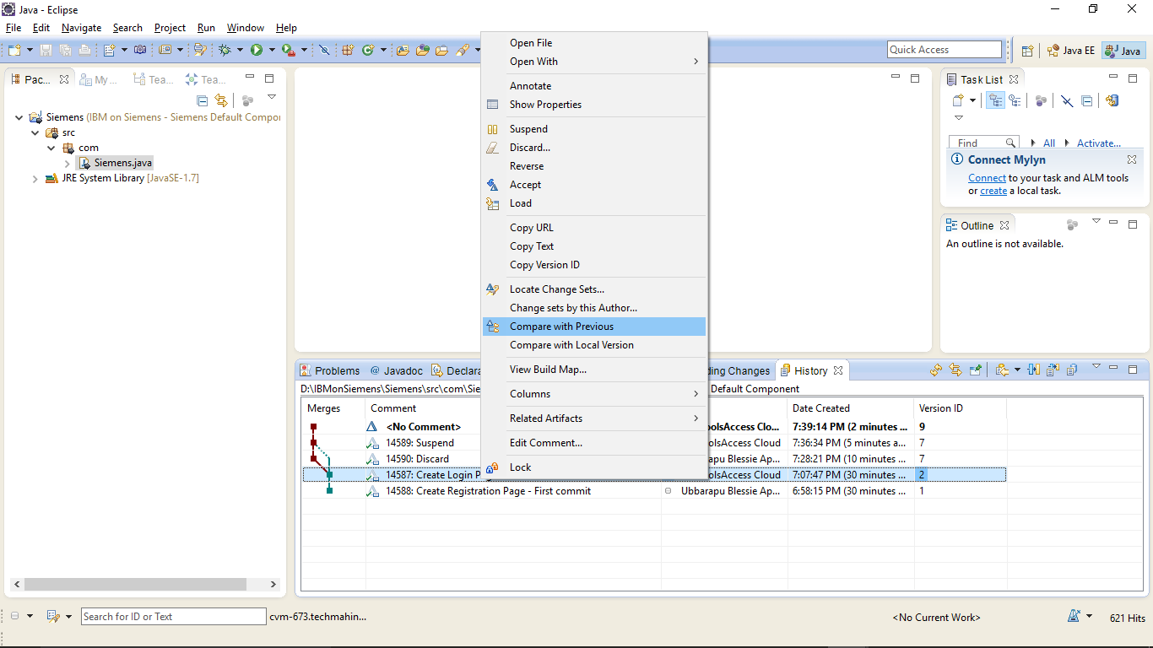

The Compare Editor will then be opened displaying the difference between the version of files.

Note how having good change set comments makes identifying points in the history of the file or folder much easier

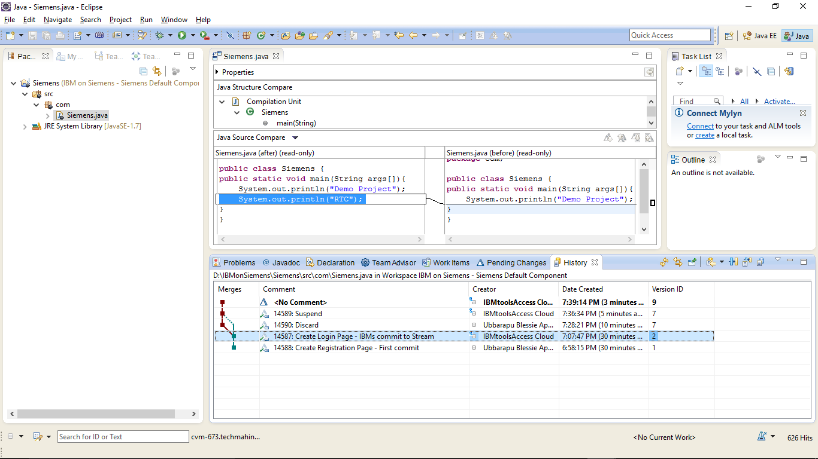

## Check-out and Check-in

RTC does not require a check-out operation before you can modify files or folders. All files in a sandbox are normally writable. Modified files remain private to your repository workspace until you deliver them.

1. To check-in the changes, go to the Pending Changes view.
2. Verify the changes and when you are ready right-click the item and select Deliver.



1. Because a change set cannot be checked-in without being associated with a work item, an error will appear in the Team Advisor view.



1. Click Associate Work Item and select the work item to be associated to the change set.



1. Perform steps 1-2 again.

## Accepting Incoming Changes

A change set is classified as incoming when it is present in a workspace flow target but not in the workspace itself. For example, you and a colleague are working on different work items for the same component. Your colleague’s fix was simple and it is complete. The change set is classified as incoming because it is not yet in your workspace.

In the Pending Changes view, incoming change sets are visible in the Incoming folder for the component. You can accept an incoming change set to add it to your repository workspace and load it into your sandbox.

If an accepted change is causing problems in your workspace, you can discard it. This action unloads it from the sandbox, removes it from the repository workspace, and returns it to the Incoming folder, effectively undoing the accept operation that added it to your workspace.

1. To accept incoming changes, go to the Pending Changes view.
2. In the Incoming folder, verify the changes and when you are ready, right-click the item and select Accept.

## Suspending Change Sets

Suspending a change set removes it from the repository workspace and unloads it from the sandbox but preserves it in the repository so that it can be restored when you want to resume work on it.

1. In the Pending Changes view, navigate to the change set that you want to suspend.
2. Right-click the change set and click Suspend.



1. The change set moves to the component's Suspended folder. New changes accumulate in a new change set, or in an existing one that you designate as current.
2. To continue working on a suspended change set, go to the Suspended folder.
3. Right-click on the suspended change set and select Resume.



## Finding and Resolving Conflicts

When Rational Team Concert source control detects that the same file exists in an outgoing change set and an incoming change set, it recognizes that a potential conflict exists and places orange icon overlays  beside the Outgoing and Incoming folders that include the conflict. A conflict is classified as a potential conflict until you accept the change set that contains it. You cannot deliver a change set that includes a potential conflict. If you accept a change set that includes a potential conflict, the potential conflict is realized, and must be resolved in your workspace.

1. In the Pending Changes view, navigate to the change set in the component's Incoming folder. When you select a file in the Incoming change set, the conflicting file in the Outgoing change set is highlighted.
2. To review the potential conflicts, right-click each file that has the potential conflict icon   
   () beside it and click Open in Compare Editor.
3. After you review the differences, take one of the following actions:

* To accept the incoming change set that contains the potential conflict, right-click it and click Accept. The  overlays are replaced  with overlays, non-conflicting files in the change set are accepted into your workspace and the potential conflicts become actual conflicts, which you must resolve.
* To suspend the outgoing change set, right-click it and click Suspend.
* To permanently remove the change that is causing the conflict, right-click the file in the outgoing change set and click Undo.
* To discard the entire outgoing change set, right-click it and click Discard.

## Viewing History of Files

The History view of a file lists all the change sets, one per line, that include the file. You can open any of these change sets in the Change Explorer view to see more detail about individual items in the change set.

1. In the Repository Files view, right click the file and select Show History.



1. Double click the selected work item to view the details.



Page Left Intentionally Blank